 **BALTIC HEATHER**

540,227 cbft / 5,778.2 sqm / built 1998

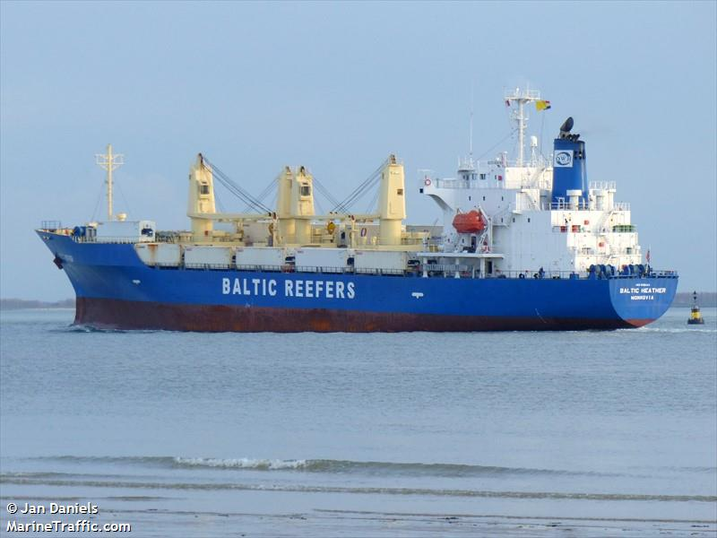

**SISTER SHIPS:**

BALTIC JASMINE  
IMO 9181156 / Built 1998

|  |  |  |
| --- | --- | --- |
|  | GT | NT |
| International | 9859 | 5124 |
| Panama canal |  | 8316 |
| Suez GRT/NRT | 10632 | 8824 |

**General**

|  |  |
| --- | --- |
| Built | June-1998 |
| Flag | Monrovia |
| Port of Registry | Monrovia |
| Call sign | D5BR9 |
| IMO/Lloyds nr | 9181144 |
| Length over all [m] | 149.92 |
| Beam[m] | 22.1 |
| Depth [m] | 13.0 |
| Bow thruster | N/A |

|  |  |  |
| --- | --- | --- |
|  | Draft | DWAT |
| Tropical | 8.898 | 10553 |
| Summer | 8.717 | 10114 |
| Winter | 8.536 | 9678 |

**Reefer**

|  |  |
| --- | --- |
| Bale cbft | 540,227 |
| Area m2 | **5,778.2** |
| Hatch covers | 4 |
| Holds/Compartments | 4/16 |
| Cooling sections | 1A/1BCD,2AB/CD,3AB/CD,4AB/CD |
| Fcsle deck | NO |
| Trunk deck | NO |
| USDA | Sensors fitted |
| PPECB | Sensors fitted |
| Reefer plugs | 58 |
| Grating load | 6 MT Axleload pneumatic tires |
| Grating | Wood |
| Temp min/max °C | -30 / +15 |
| Air circs/hour | 90 |
| Air renew/hour | 4 |

 **BALTIC HEATHER**

540,227 cbft / 5,778,2 sqm/ built 1998

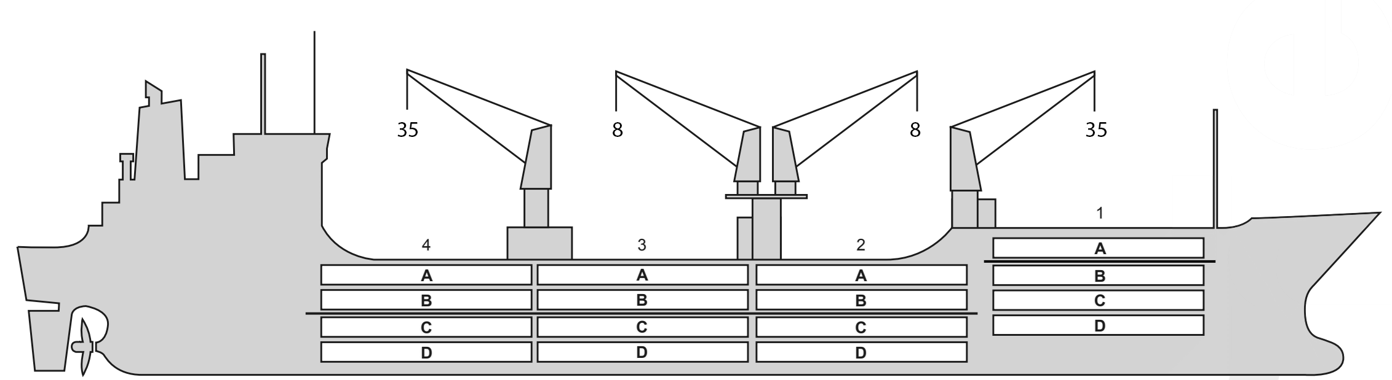

**Reefer Compartment Capacity Breakdown**

Bale capacity [cbft]

|  |  |  |  |  |
| --- | --- | --- | --- | --- |
| DECK & HATCH | 1 | 2 | 3 | 4 |
| A | 38363 | 41513 | 43200 | 42863 |
| B | 21600 | 40725 | 44663 | 44325 |
| C | 17550 | 30375 | 39825 | 30825 |
| D | 10800 | 27225 | 39600 | 26775 |
| Total | 88313 | 139838 | 167288 | 144788 |

Grand total 540,227 cbft

Deck area [m2]

|  |  |  |  |  |
| --- | --- | --- | --- | --- |
| DECK & HATCH | 1 | 2 | 3 | 4 |
| A | 414,30 | 446,56 | 468,97 | 461,50 |
| B | 245,66 | 426,65 | 463,31 | 454,96 |
| C | 177,04 | 357 | 453,01 | 368,41 |
| D | 127,85 | 268,57 | 397,80 | 246,61 |
| Total | 964,85 | 1498,78 | 1783,09 | 1531,48 |

Grand total 5,778,2 m2

Free deckheight minimum 2.20 m

Hatch sizes [m]

|  |  |  |  |
| --- | --- | --- | --- |
| Hatch | Length | Width | Insulated units |
| 1 | 7,4 | 7,4 | AB/CD |
| 2 | 7,4 | 7,4 | AB/CD |
| 3 | 7,4 | 7,4 | AB/CD |
| 4 | 7,4 | 7,4 | AB/CD |

CARGO GEAR

|  |  |  |  |
| --- | --- | --- | --- |
| No | Type | SWL mton | UP mton |
| 1,4 | Electro hydraulic | 35,0 | - |
| 2,3 | Electro hydraulic | 8,0 | - |

Max single lift cap: 2*36 MT/

MAXIMUM CONTAINER CAPACITY

|  |  |  |  |
| --- | --- | --- | --- |
|  | 20 ft (8'6'') Empty/ loaded | 40 ft (9'6'') Empty/ loaded | Stackweight 20 ft/ 40 ft |
| Weather Deck | 128/68 | 62 / 42 | 24mt/teu/ |
| Hatch covers | 32 / 32 | 16 /16 | 24mt/teu/ |
| Holds | n/a | n/a | -/- |

Reefer plugs: 58

*Above figures based on 24 MT for loaded 20 ft and 30 MT for loaded 40 ft. Actual container intake is subject to master’s approval and depending on stability, stackweight and visibility.*