 **BALTIC HOLLYHOCK**

530,147 cbft / 5,822 sqm / built 1999

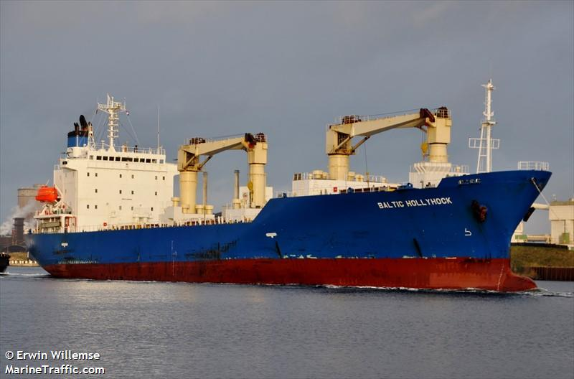

**General**

|  |  |
| --- | --- |
| Built | November-1999 |
| Flag | Liberia |
| Port of Registry | Liberia |
| Call sign | D5BX4 |
| IMO/Lloyds nr | 9189902 |
| Length over all [m] | 144.52 |
| Beam[m] | 21.80 |
| Depth [m] | 13.1 |
| Bow thruster | N/A |

|  |  |  |
| --- | --- | --- |
|  | GT | NT |
| International | 9649 | 5349 |
| Panama canal |  | 8145 |
| Suez GRT/NRT | 9649 | 5349 |

|  |  |  |
| --- | --- | --- |
|  | Draft | DWAT |
| Tropical | 9.366 | 12.258 |
| Summer | 9.175 | 11.788 |
| Winter | 8.984 | 11.322 |

**Reefer**

|  |  |
| --- | --- |
| Bale cbft | 530,147 |
| Area m2 | **5,822** |
| Hatch covers | 4 |
| Holds/Compartments | 4/16 |
| Cooling sections | 1A/BCD, 2AB/CD,3AB/CD, 4AB/CD |
| Fcsle deck | NO |
| Trunk deck | NO |
| USDA | Sensors fitted |
| PPECB | Sensors fitted |
| Reefer plugs | 80 |
| Grating load with pneumatic rubber tires | 6 MT Axle load |
| Grating | Aluminium |
| Temp min/max °C | -30 / +15 |
| Air circs/hour | 90 |
| Air renew/hour | 2.5 |



 **BALTIC HOLLYHOCK**

530,147 cbft / 5,822 sqm / built 1999

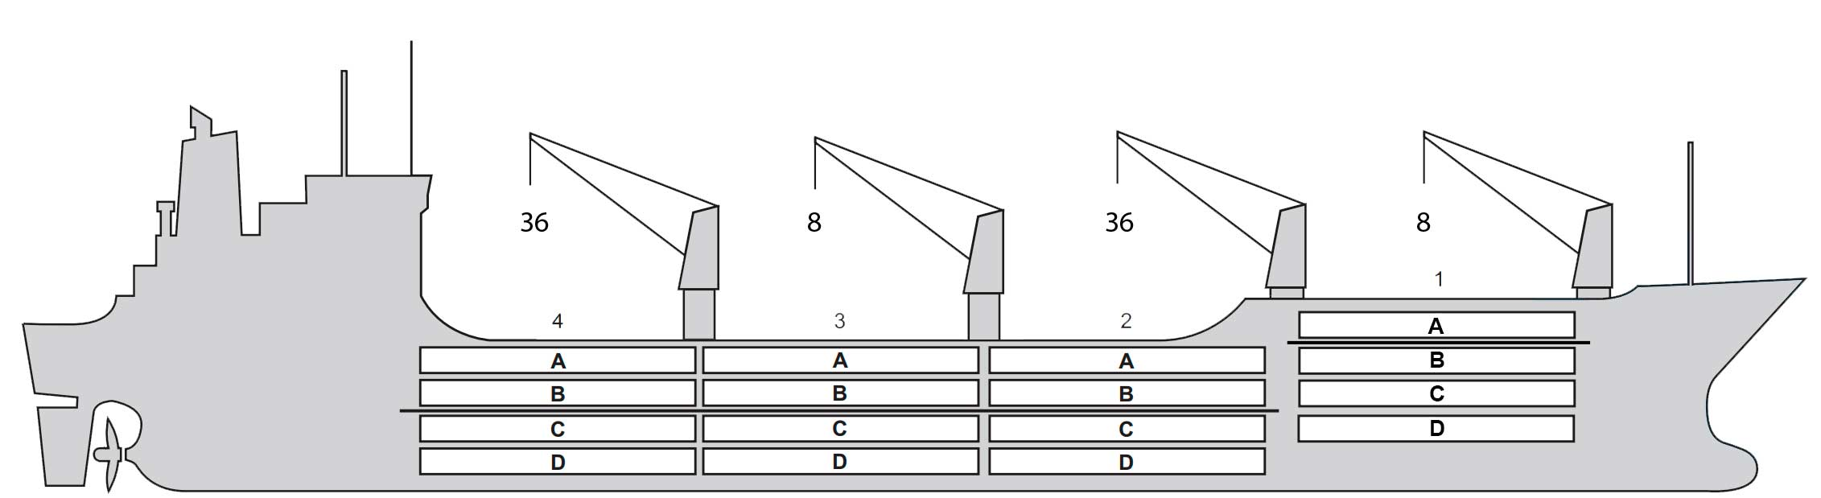

**Reefer Compartment Capacity Breakdown**

Bale capacity [cbft]

|  |  |  |  |  |
| --- | --- | --- | --- | --- |
| DECK & HATCH | 1 | 2 | 3 | 4 |
| FC |  |  |  |  |
| A | 36,225 | 37,690 | 38,475 | 37,575 |
| B | 26,550 | 36,338 | 38,812 | 38,306 |
| C | 20,475 | 30,940 | 36,450 | 32,963 |
| D | 17,775 | 31,520 | 39,645 | 30,408 |
| Total | 101,025 | 136,488 | 153,382 | 139,252 |

Grand total 530,147 cbft

Deck area [m2]

|  |  |  |  |  |
| --- | --- | --- | --- | --- |
| DECK & HATCH | 1 | 2 | 3 | 4 |
| FC |  |  |  |  |
| A | 379 | 401 | 412 | 407 |
| B | 302 | 407 | 435 | 430 |
| C | 233 | 355 | 420 | 372 |
| D | 213 | 328 | 426 | 302 |
| Total | 1,127 | 1,491 | 1,693 | 1,511 |

Grand total 5,822 m2

Free deckheight minimum 2.20m

Hatch sizes [m] CARGO GEAR

|  |  |  |  |
| --- | --- | --- | --- |
| Hatch | Length | Width | Insulated units |
| 1 | 8.1 | 6.0 | A/BCD |
| 2 | 8.1 | 6.6 | AB/CD |
| 3 | 8.1 | 6.6 | AB/CD |
| 4 | 8.1 | 6.6 | AB/CD |

|  |  |  |  |
| --- | --- | --- | --- |
| No | Type | SWL mton | UP mton |
| 2 | Electro hydraulic | 36,0 | - |
| 2 | Electro hydraulic | 8,0 |  |

MAXIMUM CONTAINER CAPACITY

|  |  |  |  |
| --- | --- | --- | --- |
|  | 20 ft (8'6'') | 40 ft (9'6'') | Stackweight 20 ft/ 40 ft |
| WeatherDeck | 120/80 | 60/40 | 50,8 / 81,2 |
| Hatchcovers | 0/0 | 28/28 | / 55,9 |
| Holds | 0 /0 | 0/0 | -/- |

Reefer plugs: 80

*Above figures based on 14M for loaded 20 ft and 27MT for loaded 40 ft Suvject Master approval, Stability & Visibility*