**BALTIC LADY**

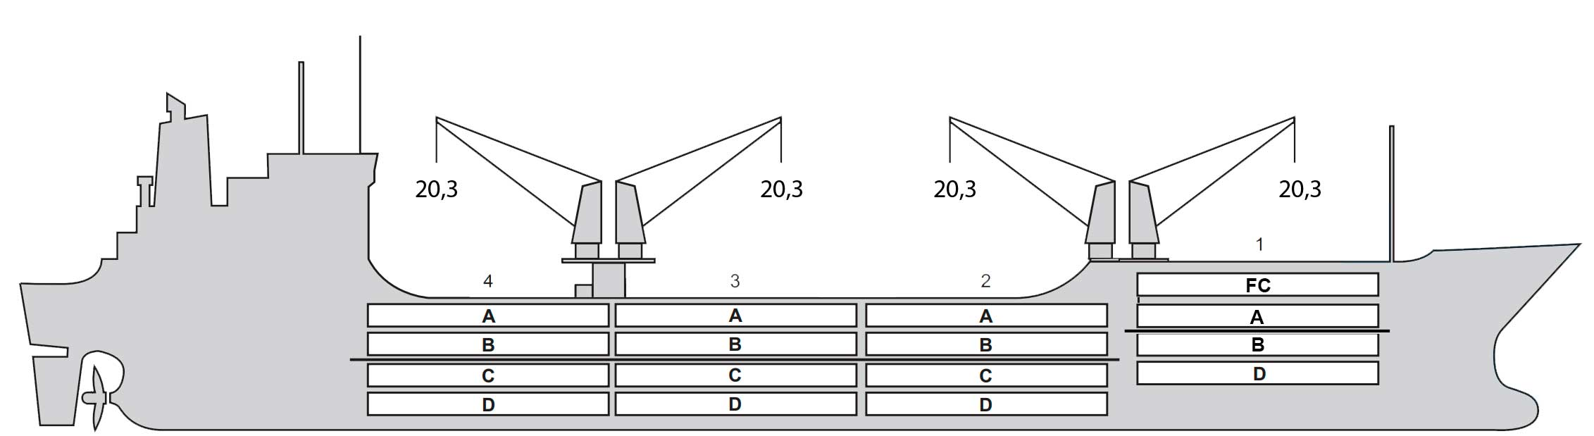

**BASICS**

|  |  |
| --- | --- |
| Flag | BAHAMAS |
| LLoyds no. | 9160736 |
| Class | RINA |
| Int GRT/NRT | 11,443 / 6,336 |
| Pan GRT/NRT | /9,880 |
| Suez GRT/NRT | 12,304 / 9,166 |
| Built | 2000 |
| Length over all m | 155.25 |
| Breadth moulded m | 23.40 |
| Depth W.D. m | 13.2 |
| Sdwt mton | 12,913 |
| Draught sdwt m | 9.50 |
| Bale cbft | 590,227 |
| Area m2 | 6,906 |
| Bow thruster | N/A |
| Hatch covers | 4 |
| Holds/Compartments | 4/1 6 |
| Fcsle deck | YES |
| Trunk deck | NO |
| USDA | Sensors fitted |
| PPECB | Sensors fitted |
| Reefer plugs | 120 |
| Grating load | 7 MT Axleload |
|  | Pneumatic tires |
| Grating | Aluminium |
| Temp min/max °C | -30 / 15 |
| Air circs/hour | 90 |
| Air renew/hour | 2.5 |
|  |  |

**BALE cbft**

|  |  |  |  |  |
| --- | --- | --- | --- | --- |
| DECK & HATCH | 1 | 2 | 3 | 4 |
| FC | 43,067 |  |  |  |
| A | 34,501 | 47,526 | 47,392 | 48,750 |
| B | 21,370 | 42,896 | 42,817 | 46,963 |
| C | 16,515 | 36,841 | 42,493 | 36,922 |
| D |  | 24,787 | 33,750 | 23,617 |
| Total | 115,453 | 152,050 | 166,452 | 156,272 |

Grand total 590,227

**DECK AREA m2**

|  |  |  |  |  |
| --- | --- | --- | --- | --- |
| DECK & HATCH | 1 | 2 | 3 | 4 |
| FC | 466 |  |  |  |
| A | 357 | 540 | 534 | 558 |
| B | 241 | 504 | 534 | 540 |
| C | 173 | 444 | 530 | 445 |
| D |  | 313 | 425 | 302 |
| Total | 1237 | 1,801 | 2,023 | 1,845 |

Grand total 6,906

Free deckheight minimum 2.20 m

**HATCHES (Weather deck) m**

|  |  |  |  |
| --- | --- | --- | --- |
| Hatch | Length | Width | Insulated units |
|  |  |  |  |
| 1 | 6.16 | 6.0 | 1FA/BC |
| 2 | 12.8 | 8.0 | AB/CD |
| 3 | 12.8 | 8.0 | AB/CD |
| 4 | 12.8 | 8.0 | AB/CD |

Insulated units are separate cooling sections.

**BALTIC LADY**

**CARGO GEAR**

|  |  |  |  |
| --- | --- | --- | --- |
| No of | Type | SWL mton | UP mton |
| 4 | Electro hydraulic | 20 | - |

Max single lift cap: 2 x 20 MT / 2 x 20 MT

Max twin lift cap : 40MT

**MAXIMUM CONTAINER CAPACITY**

|  |  |  |  |
| --- | --- | --- | --- |
|  | 20 ft (8'6'') Empty/ loaded | 40 ft (9'6'') Empty/ loaded | Stackweight 20 ft/ 40 ft |
| Weather Deck | 150/150 | 74/74 | 72,0 / 90,0 |
| Hatch covers | 18/18 | 46/46 | / 30,0 |
| Holds | 72 / 72 | 36/36 | 96 / 120 |

Reefer plugs: 120

Above figures based on 14 M for loaded 20 ft and 25 MT for loaded 40 ft Subject Master approval, Stability & Visibility

All details believed to be correct but not guaranteed