 **BALTIC PATRIOT**

527,422 cbft / 5,853 sqm /built 1992

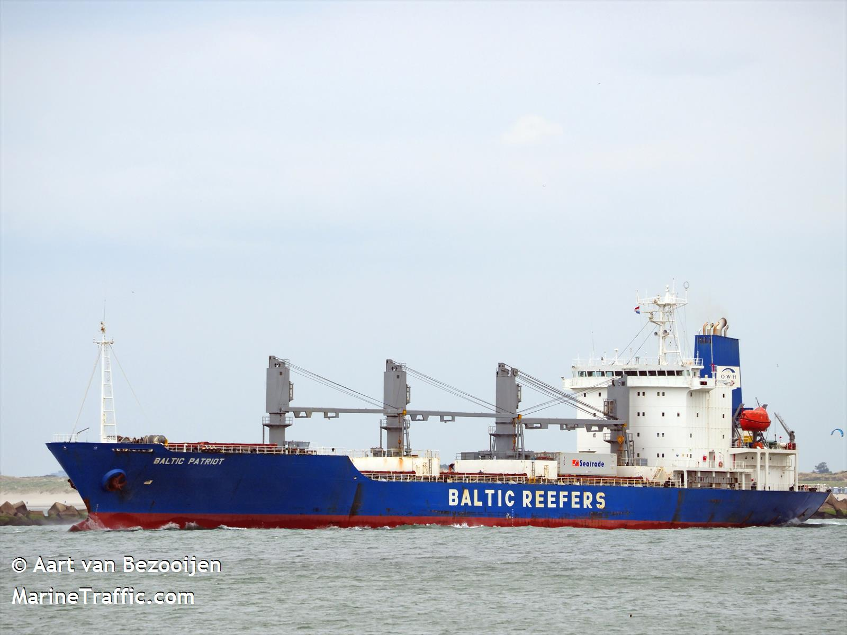

**SISTER SHIPS:**

BALTIC PEARL  
 IMO 9038488 / Built 1988

BALTIC PERFORMER   
IMO 9038488 / Built 1988

|  |  |  |
| --- | --- | --- |
|  | GT | NT |
| International | 10402 | 5265 |
| Panama canal |  | 8541 |
| Suez GRT/NRT |  | 8797,6 |

**General**

|  |  |
| --- | --- |
| Built | October – 1992 |
| Flag | Liberia |
| Port of Registry | Monrovia |
| Call sign | D5BR9 |
| IMO/Lloyds nr | 9038488 |
| Length over all [m] | 150,01 |
| Beam[m] | 22,53 |
| Depth [m] | 8,843 |
| Bow thruster | N/A |

|  |  |  |
| --- | --- | --- |
|  | Draft | DWAT |
| Tropical | 9 | 7,726 |
| Summer | 8,5 | 7,721 |
| Winter | 8 | 7,711 |

**Reefer**

|  |  |
| --- | --- |
| Bale cbft | 527,422 |
| Area m2 | **5,853** |
| Hatch covers | 4 |
| Holds/Compartments | 15 |
| Cooling sections | 1F,1AB,2AB,2CD,3AB,3CD,4AB,4CD |
| Fcsle deck | YES |
| Trunk deck | NO |
| USDA | Sensors fitted |
| PPECB | Sensors fitted |
| Reefer plugs | 55 |
| Grating load | 6 MT Axleload pneumatic tires |
| Grating | Wood |
| Temp min/max °C | -30/+15 |
| Air circs/hour | 90 |
| Air renew/hour | 2 |

 **BALTIC PATRIOT**

527,422 cbft / 5,853 sqm / built 1992

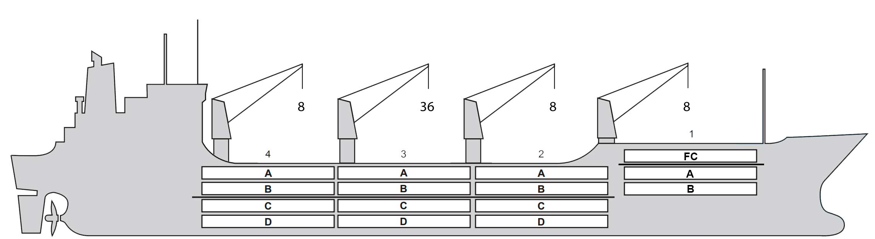

**Reefer Compartment Capacity Breakdown**

Bale capacity [cbft]

|  |  |  |  |  |
| --- | --- | --- | --- | --- |
| DECK & HATCH | 1 | 2 | 3 | 4 |
| FC | 38606 |  |  |  |
| A | 26790 | 43127 | 44055 | 45609 |
| B | 17046 | 35480 | 38722 | 37440 |
| C |  | 31762 | 38376 | 34943 |
| D |  | 27874 | 36628 | 30964 |
| Total | 82442 | 138243 | 157781 | 148956 |

Grand total 527,422 cbft

Deck area [m2]

|  |  |  |  |  |
| --- | --- | --- | --- | --- |
| DECK & HATCH | 1 | 2 | 3 | 4 |
| FC | 373 |  |  |  |
| A | 260 | 441 | 460 | 464 |
| B | 178 | 418 | 463 | 444 |
| C |  | 379 | 461 | 413 |
| D |  | 315 | 435 | 349 |
| Total | 811 | 1553 | 1819 | 1670 |

Grand total 5,853 m2

Free deckheight minimum 2.20 m

Hatch sizes [m]

|  |  |  |  |
| --- | --- | --- | --- |
| Hatch | Length | Width | Insulated units |
| 1 | 13,0 | 8,5 | FC/AB |
| 2 | 13,0 | 10,3 | AB/CD |
| 3 | 13,0 | 10,3 | AB/CD |
| 4 | 13,0 | 10,3 | AB/CD |

CARGO GEAR

|  |  |  |  |
| --- | --- | --- | --- |
| No | Type | SWL mton | UP mton |
| 1,2,4 | Electro hydraulic | 8 | - |
| 3 | Electro hydraulic | 36 | - |

Max single lift cap: N/A

Max twin lift cap : N/A

MAXIMUM CONTAINER CAPACITY

|  |  |  |  |
| --- | --- | --- | --- |
|  | 20 ft (8'6'') Empty/ loaded | 40 ft (9'6'') Empty/ loaded | Stackweight 20 ft/ 40 ft |
| Weather Deck | 68/44 | 34 / 22 | 20 / 30,60 |
| Hatch covers | 72 / 68 | 38 /34 | 20 / 30,60 |
| Holds | 108/ 108 | 54 / 54 | (40,20)/  (60,30) |

Reefer plugs: 55

*Above figures based on 14 MT for loaded 20 ft and 30 MT for loaded 40 ft. Actual container intake is subject to master’s approval and depending on stability, stackweight and visibility.*