**BALTIC PERFORMER**

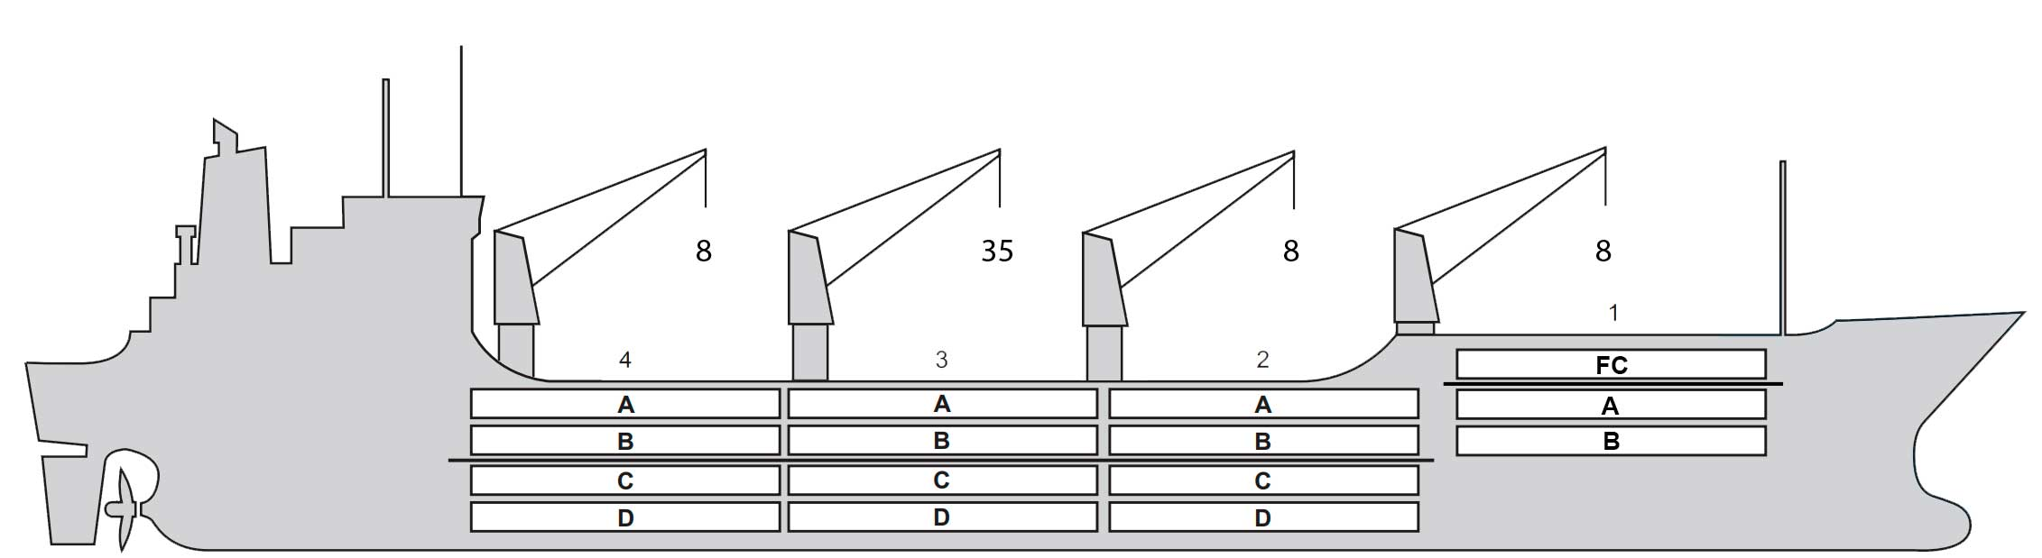

**BASICS**

|  |  |
| --- | --- |
| Flag | Bahamas |
| LLoyds no. | 9016674 |
| Class | RINA |
| Int GRT/NRT | 10,381 / 5,253 |
| Pan GRT/NRT | 11,397 / 8,688 |
| Suez GRT/NRT | 11,027 / 8,446 |
| Built | 1992 |
| Length over all m | 150.01 |
| Breadth moulded m | 22.50 |
| Depth W.D. m | 13.2 |
| Sdwt mton | 10,602 |
| Draught sdwt m |  |
| Bale cbft | 526,764 |
| Area m2 | 5,850 |
| Bow thruster | N/A |
| Hatch covers | 4 |
| Holds/Compartments | 4 / 16 |
| Fcsle deck | YES |
| Trunk deck | NO |
| USDA | Sensors fitted |
| PPECB | Sensors fitted |
| Reefer plugs | 54 |
| Grating load | 5 MT Axleload |
|  | Pneumatic tires |
| Grating | Wodden |
| Temp min/max °C | -30 / 15 |
| Air circs/hour | 90 |
| Air renew/hour | 2.5 |
|  |  |

**BALE cbft**

|  |  |  |  |  |
| --- | --- | --- | --- | --- |
| DECK & HATCH | 1 | 2 | 3 | 4 |
| FC | 38,822 |  |  |  |
| A | 26,772 | 43,042 | 43,960 | 45,574 |
| B | 16,993 | 35,464 | 38,649 | 37,384 |
| C |  | 31,710 | 38,271 | 34,944 |
| D |  | 27,779 | 36,513 | 30,887 |
| Total | 82,587 | 137,995 | 157,393 | 148,789 |

Grand total 526,764

**DECK AREA m2**

|  |  |  |  |  |
| --- | --- | --- | --- | --- |
| DECK & HATCH | 1 | 2 | 3 | 4 |
| FC | 376 |  |  |  |
| A | 260 | 440 | 459 | 464 |
| B | 178 | 419 | 462 | 444 |
| C |  | 378 | 461 | 413 |
| D |  | 314 | 434 | 348 |
| Total | 814 | 1,551 | 1,816 | 1,669 |

Grand total 5,850

Free deckheight minimum 2.20 m

**HATCHES (Weather deck) m**

|  |  |  |  |
| --- | --- | --- | --- |
| Hatch | Length | Width | Insulated units |
|  |  |  |  |
| 1 | 13.0 | 8.6 | FAB |
| 2 | 13.0 | 10.3 | AB/CD |
| 3 | 13.0 | 10.3 | AB/CD |
| 4 | 13.0 | 10.3 | AB/CD |

Insulated units are separate cooling sections.

**BALTIC PERFORMER**

**CARGO GEAR**

|  |  |  |  |
| --- | --- | --- | --- |
| No of | Type | SWL mton | UP mton |
| 3 | Electro hydraulic | 8,0 | - |
| 1 | Electro hydraulic | 35,0 |  |

Max single lift cap: 2 x 35 MT / 2 x 8 MT

**MAXIMUM CONTAINER CAPACITY**

|  |  |  |  |
| --- | --- | --- | --- |
|  | 20 ft (8'6'') Empty/ loaded | 40 ft (9'6'') Empty/ loaded | Stackweight 20 ft/ 40 ft |
| Weather Deck | 48/48 | 28/28 | 20/78 |
| Hatch covers | 86/86 | 37/37 | 20/76 |
| Holds | 108/108 | 54/54 | -/- |

Reefer plugs: 54

Above figures based on 14 M for loaded 20 ft and 27 MT for loaded 40 ft Subject Master approval, Stability & Visibility

All details believed to be correct but not guaranteed