 **BALTIC PURPLE**

566,248 cbft / 6518 sqm / built 1996

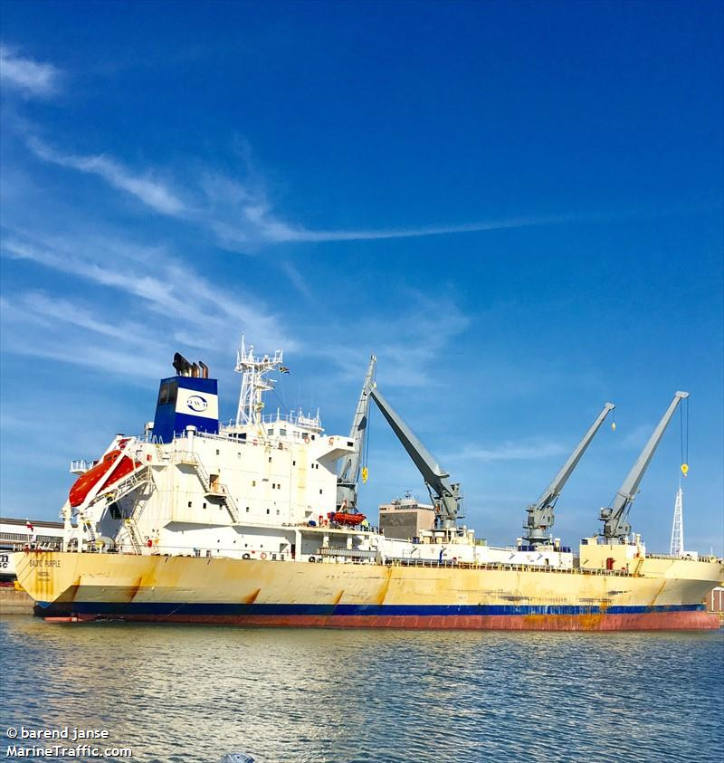

**General**

|  |  |
| --- | --- |
| Built | December-1996 |
| Flag | Bahamas |
| Port of Registry | Bahamas |
| Call sign | C6DN3 |
| IMO/Lloyds nr | 9143099 |
| Length over all [m] | 154 |
| Beam[m] | 24 |
| Depth [m] | 8,6 |
| Bow thruster | N/A |

|  |  |  |
| --- | --- | --- |
|  | Draft | DWAT |
| Tropical | 9,206 | 10,964 |
| Summer | 9,018 | 10,432 |
| Winter | 8,83 | 9,9 |

|  |  |  |
| --- | --- | --- |
|  | GT | NT |
| International | 11438 | 5901 |
| Panama canal |  | 9625 |
| Suez GRT/NRT |  | 5901 |

**Reefer**

|  |  |
| --- | --- |
| Bale cbft | 566,248 |
| Area m2 | **6518** |
| Hatch covers | 4 |
| Holds/Compartments | 4/16 |
| Cooling sections | 1F,1ABC,2AB,2CD,3AB,3CD,4AB,4CD |
| Fcsle deck | NO |
| Trunk deck | NO |
| USDA | Sensors fitted |
| PPECB | Sensors fitted |
| Reefer plugs | 70 |
| Grating load | 6 MT Axle load with pneumatic rubber tires |
| Grating | Wood |
| Temp min/max °C | -25/+15 |
| Air circs/hour | 90 |
| Air renew/hour | 2 |

 **BALTIC PURPLE**

566,248 cbft / 6518 sqm / Built 1996

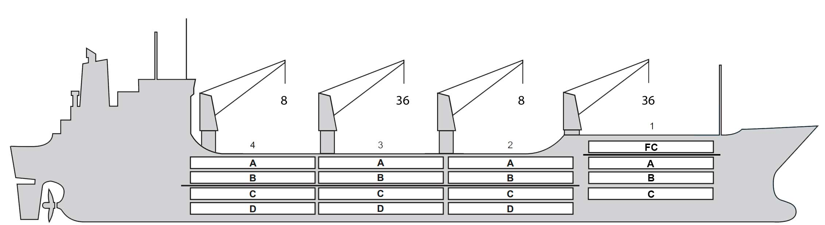

**Reefer Compartment Capacity Breakdown**

Bale capacity [cbft]

|  |  |  |  |  |
| --- | --- | --- | --- | --- |
| DECK & HATCH | 1 | 2 | 3 | 4 |
| FC | 48240 |  |  |  |
| A | 32825 | 44323 | 44140 | 47735 |
| B | 17241 | 35866 | 40810 | 41057 |
| C | 10905 | 30929 | 38504 | 36134 |
| D |  | 28979 | 36346 | 32214 |
| Total | 109211 | 140097 | 159800 | 157140 |

Grand total 566,248 cbft

Deck area [m2]

|  |  |  |  |  |
| --- | --- | --- | --- | --- |
| DECK & HATCH | 1 | 2 | 3 | 4 |
| FC | 535 |  |  |  |
| A | 316 | 477 | 488 | 532 |
| B | 208 | 432 | 489 | 493 |
| C | 126 | 385 | 482 | 434 |
| D | - | 327 | 438 | 355 |
| Total | 1185 | 1621 | 1897 | 1815 |

Grand total 6518 m2

Free deckheight minimum 2.20m

Hatch sizes [m]

|  |  |  |  |
| --- | --- | --- | --- |
| Hatch | Length | Width | Insulated units |
| 1 | 12.6 | 8.0 | F/ABC |
| 2 | 12.6 | 8.0 | AB/CD |
| 3 | 12.6 | 8.0 | AB/CD |
| 4 | 12.6 | 8.0 | AB/CD |

CARGO GEAR

|  |  |  |  |
| --- | --- | --- | --- |
| No | Type | SWL mton | UP mton |
| 1,3 | Electro hydraulic | 36,0 | - |
| 2,4 | Electro hydraulic | 8,0 |  |

MAXIMUM CONTAINER CAPACITY

|  |  |  |  |
| --- | --- | --- | --- |
|  | 20 ft (8'6'') | 40 ft (9'6'') | Stackweight 20 ft/ 40 ft |
| WeatherDeck | 118/118 | 56/56 | 60 / 90 (20/30-F’le) |
| Hatchcovers | 56/48 | 28/24 | 40 / 60 |
| Holds | 84/84 | 42/42 | 80 / 120 (40/60-CC1) |

Reefer plugs: 70

*Above figures based on 14MT for loaded 20 ft and 27MT for loaded 40 ft Suvject Master approval, Stability & Visibility*