 **BALTIC SUMMER**

592,295 cbft / 6,888 sqm / built 1989

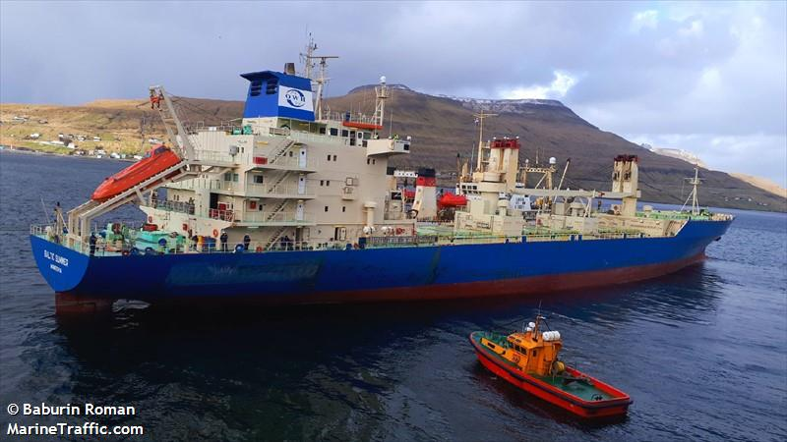

**SISTER SHIPS:**

BALTIC SPRING  
IMO 8909070 / Built 1991

BALTIC WINTER   
 IMO 9014755 / Built 1992

BALTIC AUTUMN

IMO 90114767 / Built 1993

**General**

|  |  |  |
| --- | --- | --- |
|  | GT | NT |
| International | 10842 | 6381 |
| Panama canal | 11981 | 9670 |
| Suez GRT/NRT | 11599 | 9580,9 |

|  |  |
| --- | --- |
| Built | May – 1989 |
| Flag | Liberia |
| Port of Registry | Liberia |
| Call sign | ELWR5 |
| IMO/Lloyds nr | 8802090 |
| Length over all [m] | 156,88 |
| Beam[m] | 23 |
| Depth [m] | 13,2 |
| Bow thruster | N/A |

|  |  |  |
| --- | --- | --- |
|  | Draft | DWAT |
| Tropical | 9,529 | 12,942 |
| Summer | 9,529 | 12,942 |
| Winter | 9,699 | 12,942 |

**Reefer**

|  |  |
| --- | --- |
| Bale cbft | 592,295 |
| Area m2 | **6,888** |
| Hatch covers | 4 |
| Holds/Compartments | 4/16 |
| Cooling sections | 1AB,1CD, 2AB, 2CD, 3AB, 3CD, 4AB, 4CD |
| Fcsle deck | NO |
| Trunk deck | NO |
| USDA | Sensors fitted |
| PPECB | Sensors fitted |
| Reefer plugs | 102 |
| Grating load | 6 MT Axleload pneumatic tires |
| Grating | Aluminium |
| Temp min/max °C | -30/+15 |
| Air circs/hour | 90 |
| Air renew/hour | 2,5 |



**BALTIC SUMMER**

592,295 cbft / 6,888 sqm / built 1989

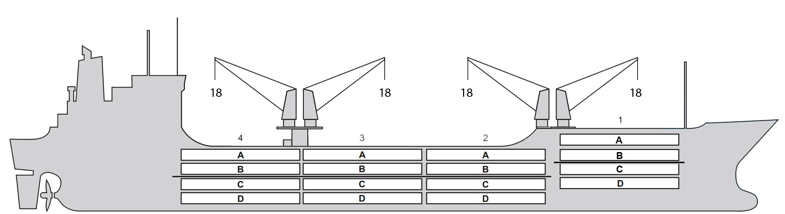

**Reefer Compartment Capacity Breakdown**

Bale capacity [cbft]

|  |  |  |  |  |
| --- | --- | --- | --- | --- |
| DECK & HATCH | 1 | 2 | 3 | 4 |
| FC |  |  |  |  |
| A | 50,489 | 41,491 | 36,872 | 41,103 |
| B | 43,150 | 40,317 | 37,496 | 41,918 |
| C | 30,265 | 36,280 | 35,831 | 36,179 |
| D | 21,096 | 32,602 | 35,296 | 31,910 |
| Total | 145,000 | 150,690 | 145,495 | 151,110 |

Grand total 592,295 cbft

Deck area [m2]

|  |  |  |  |  |
| --- | --- | --- | --- | --- |
| DECK & HATCH | 1 | 2 | 3 | 4 |
| FC |  |  |  |  |
| A | 674 | 494 | 441 | 491 |
| B | 469 | 477 | 448 | 482 |
| C | 346 | 438 | 441 | 426 |
| D | 219 | 343 | 386 | 313 |
| Total | 1,708 | 1,752 | 1,716 | 1,712 |

Grand total 6,888 m2

Free deckheight minimum 2.20 m

Hatch sizes [m]

|  |  |  |  |
| --- | --- | --- | --- |
| Hatch | Length | Width | Insulated units |
| 1 | 9.3 | 7.6 | AB/CD |
| 2 | 12.5 | 7.6 | AB/CD |
| 3 | 12.5 | 7.6 | AB/CD |
| 4 | 12.5 | 7.6 | AB/CD |

CARGO GEAR

|  |  |  |  |
| --- | --- | --- | --- |
| No of | Type | SWL mton | UP mton |
| 2 | Electro hydraulic | 18,0 | - |
| 2 | Electro hydraulic | 18,0 |  |

Max single lift cap: 2 x 18 MT / 2 x 18 MT

Max twin lift cap: 32.00 MT

MAXIMUM CONTAINER CAPACITY

|  |  |  |  |
| --- | --- | --- | --- |
|  | 20 ft (8'6'') Empty/ loaded | 40 ft (9'6'') Empty/ loaded | Stackweight 20 ft/ 40 ft |
| Weather Deck | 134/94 | 66/46 | 40,0 / 60,0 |
| Hatch covers | 72/64 | 30/26 | 40 / 60,0 |
| Holds | 84 /84 | 27/27 | 80 / 120 |

Reefer plugs: 78

*Above figures based on 14 MT for loaded 20 ft and 25 MT for loaded 40 ft. Actual container intake is subject to master’s approval and depending on stability, stackweight and visibility.*