**BALTIC WINTER**

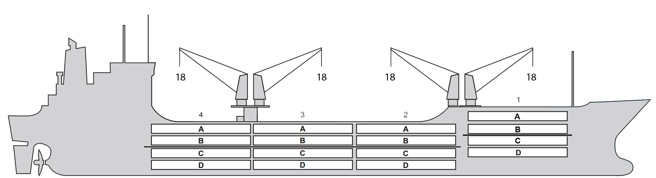

**BASICS**

|  |  |
| --- | --- |
| Flag | Bahamas |
| LLoyds no. | 9014755 |
| Class | RINA |
| Int GRT/NRT | 10,842 / 6,381 |
| Pan GRT/NRT | 11,973/9,353 |
| Suez GRT/NRT | 11,599 / 9,426 |
| Built | 1992 |
| Length over all m | 156.53 |
| Breadth moulded m | 23.00 |
| Depth W.D. m | 13.2 |
| Sdwt mton | 12,890 |
| Draught sdwt m | 9.50 |
| Bale cbft | 592,295 |
| Area m2 | 6,888 |
| Bow thruster | N/A |
| Hatch covers | 4 |
| Holds/Compartments | 4 / 16 |
| Fcsle deck | NO |
| Trunk deck | NO |
| USDA | Sensors fitted |
| PPECB | Sensors fitted |
| Reefer plugs | 102 |
| Grating load | 6 MT Axleload |
|  | Pneumatic tires |
| Grating | Aluminium |
| Temp min/max °C | -30 / 15 |
| Air circs/hour | 90 |
| Air renew/hour | 2.5 |
|  |  |

**BALE cbft**

|  |  |  |  |  |
| --- | --- | --- | --- | --- |
| DECK & HATCH | 1 | 2 | 3 | 4 |
| FC |  |  |  |  |
| A | 50,489 | 41,491 | 36,872 | 41,103 |
| B | 43,150 | 40,317 | 37,496 | 41,918 |
| C | 30,265 | 36,280 | 35,831 | 36,179 |
| D | 21,096 | 32,602 | 35,296 | 31,910 |
| Total | 145,000 | 150,690 | 145,495 | 151,110 |

Grand total 592,295

**DECK AREA m2**

|  |  |  |  |  |
| --- | --- | --- | --- | --- |
| DECK & HATCH | 1 | 2 | 3 | 4 |
| FC |  |  |  |  |
| A | 585 | 494 | 441 | 491 |
| B | 469 | 477 | 448 | 482 |
| C | 346 | 438 | 441 | 426 |
| D | 219 | 343 | 386 | 313 |
| Total | 1,619 | 1,752 | 1,716 | 1,712 |

Grand total 6,799

Free deckheight minimum 2.20 m

**HATCHES (Weather deck) m**

|  |  |  |  |
| --- | --- | --- | --- |
| Hatch | Length | Width | Insulated units |
|  |  |  |  |
| 1 | 9.3 | 7.6 | AB/CD |
| 2 | 12.5 | 7.6 | AB/CD |
| 3 | 12.5 | 7.6 | AB/CD |
| 4 | 12.5 | 7.6 | AB/CD |

Insulated units are separate cooling sections.

**BALTIC WINTER**

**CARGO GEAR**

|  |  |  |  |
| --- | --- | --- | --- |
| No of | Type | SWL mton | UP mton |
| 2 | Electro hydraulic | 18,0 | - |
| 2 | Electro hydraulic | 18,0 |  |

Max single lift cap: 2 x 18 MT / 2 x 18 MT

Max twin lift cap : 36.00

**MAXIMUM CONTAINER CAPACITY**

|  |  |  |  |
| --- | --- | --- | --- |
|  | 20 ft (8'6'') Empty/ loaded | 40 ft (9'6'') Empty/ loaded | Stackweight 20 ft/ 40 ft |
| Weather Deck | 146/134 | 92/70 | 40,0 /75,0 |
| Hatch covers | 88/76 | 52/32 | 40 / 60,0 |
| Holds | 84 /84 | 27/27 | 80 / 120 |

Reefer plugs: 102

Above figures based on 14 M for loaded 20 ft and 25 MT for loaded 40 ft Subject Master approval, Stability & Visibility

Please contact Cool Carriers Ltd for information about speed and consumption

All details believed to be correct but not guaranteed