**BALTIC JASMINE**

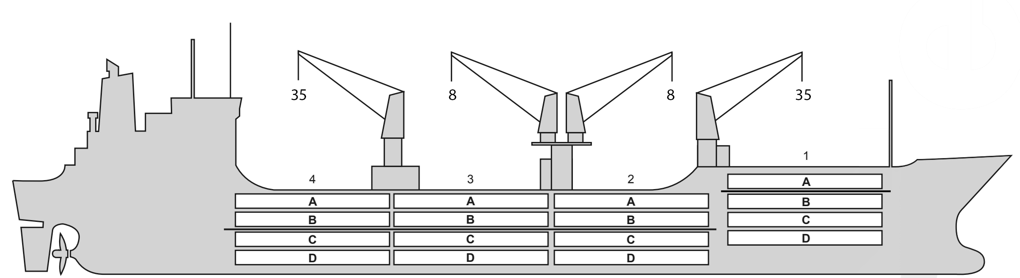

**BASICS**

|  |  |
| --- | --- |
| Flag | Limassol  Cyprus |
| LLoyds no. | 9181156 |
| Class | RMRS |
| Int GRT/NRT | 9859 / 5124 |
| Pan GRT/NRT | / 8316 |
| Suez GRT/NRT | 10632.00/8637.55 |
| Built | 1998 |
| Length over all m | 149.92 |
| Breadth moulded m | 22.1 |
| Depth W.D. m | 13.0 |
| Sdwt mton | 10114 |
| Draught sdwt m | 8.72 |
| Bale cbft | 540,227 |
| Area m2 | 5,778.2 |
| Bow thruster | N/A |
| Hatch covers | 4 |
| Holds/Compartments | 4 / 16 |
| Fcsle deck | NO |
| Trunk deck | NO |
| USDA | Sensors fitted |
| PPECB | Sensors fitted |
| Reefer plugs | 58 |
| Grating load | 6 MT Axleload |
|  | Pneumatic tires |
| Grating | wood |
| Temp min/max °C | -30 / 15 |
| Air circs/hour | 90 |
| Air renew/hour | 4 |
|  |  |

**BALE cbft**

|  |  |  |  |  |
| --- | --- | --- | --- | --- |
| DECK & HATCH | 1 | 2 | 3 | 4 |
| A | 38363 | 41513 | 43200 | 42863 |
| B | 21600 | 40725 | 44663 | 44325 |
| C | 17550 | 30375 | 39825 | 30825 |
| D | 10800 | 27225 | 39600 | 26775 |
| Total | 88313 | 139838 | 167288 | 144788 |

Grand total 540,227

**DECK AREA m2**

|  |  |  |  |  |
| --- | --- | --- | --- | --- |
| DECK & HATCH | 1 | 2 | 3 | 4 |
| A | 414,30 | 446,56 | 468,97 | 461,50 |
| B | 245,66 | 426,65 | 463,31 | 454,96 |
| C | 177,04 | 357,00 | 453,01 | 368,41 |
| D | 127,85 | 268,57 | 397,80 | 246,61 |
| Total | 964,85 | 1498,78 | 1783,09 | 1531,48 |

Grand total 5,778.2

Free deckheight minimum 2.20 m

**HATCHES (Weather deck) m**

|  |  |  |  |
| --- | --- | --- | --- |
| Hatch | Length | Width | Insulated units |
|  |  |  |  |
| 1 | 7.4 | 7.4 | AB/CD |
| 2 | 7.4 | 7.4 | AB/CD |
| 3 | 7.4 | 7.4 | AB/CD |
| 4 | 7.4 | 7.4 | AB/CD |

Insulated units are separate cooling sections.

**BALTIC JASMINE**

**CARGO GEAR**

|  |  |  |  |
| --- | --- | --- | --- |
| No of | Type | SWL mton | UP mton |
| 1,4 | Electro hydraulic | 35,0 | - |
| 2,3 | Electro hydraulic | 8,0 |  |

Max single lift cap: 2 x 36 MT / 2 x 8 MT

**MAXIMUM CONTAINER CAPACITY**

|  |  |  |  |
| --- | --- | --- | --- |
|  | 20 ft (8'6'') Empty/ loaded | 40 ft (9'6'') Empty/ loaded | Stackweight 20 ft/ 40 ft |
| Weather Deck | 128/68 | 62/42 | 24mt/teu / |
| Hatch covers | 32/32 | 16/16 | 24mt/teu / |
| Holds | n/a | n/a | -/- |

Reefer plugs: 58

Above figures based on 14 MT for loaded 20 ft and 27 MT for loaded 40 ft Subject Master approval, Stability & Visibility

All details believed to be correct but not guaranteed