**BALTIC SPIRIT**

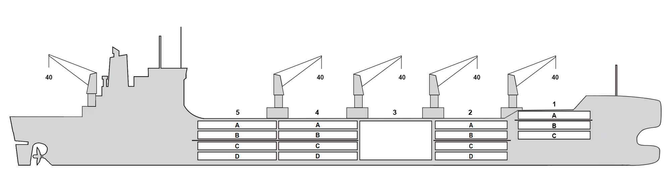

**BASICS**

|  |  |
| --- | --- |
| Flag | Bahamas/ Nassau |
| LLoyds no. | 9765873 |
| Class | NK NS |
| Int GRT/NRT | 17,421 / 8,092 |
| Pan GRT/NRT | / 8092 |
| Suez GRT/NRT | 18’038 / 14’827 |
| Built | 2018 |
| Length over all m | 188.6 |
| Breadth moulded m | 26 |
| Depth W.D. m | 14.1 |
| Sdwt mton | 16727 |
| Draught sdwt m | 9.72 |
| Bale cbft | 653,310 |
| Area m2 | 7,290.7 |
| Bow thruster | Fore |
| Hatch covers | 5 |
| Holds/Compartments | 4/15+container hold No.3 |
| Fcsle deck | NO |
| Trunk deck | NO |
| USDA | Sensors fitted |
| PPECB | Sensors fitted |
| Reefer plugs | 320 |
| Grating load | 7 MT Axleload |
|  | Pneumatic tires |
| Grating | wood |
| Temp min/max °C | -30 / +15 |
| Air circs/hour | 90 |
| Air renew/hour | 2 |
|  |  |

**BALE cbft**

|  |  |  |  |  |
| --- | --- | --- | --- | --- |
| DECK & HATCH | 1 | 2 | 4 | 5 |
| FC | 52301 |  |  |  |
| A | 29262 | 55000 | 54993 | 55314 |
| B | 16842 | 43232 | 52167 | 50514 |
| C |  | 37550 | 51631 | 44052 |
| D |  | 30530 | 41891 | 38031 |
| Total | 98405 | 166312 | 200682 | 187911 |

Grand total 653,310

**DECK AREA m2**

|  |  |  |  |  |
| --- | --- | --- | --- | --- |
| DECK & HATCH | 1 | 2 | 4 | 5 |
| FC | 551.7 |  |  |  |
| A | 311.2 | 570.4 | 573.5 | 574.9 |
| B | 193.3 | 490.6 | 619.9 | 571.4 |
| C |  | 440.2 | 618.7 | 525.7 |
| D |  | 349.7 | 470.5 | 429 |
| Total |  | 1850.9 | 2282.6 | 2101 |

Grand total 7290.7

Free deckheight minimum 2.30 m

**HATCHES (Weather deck) m**

|  |  |  |  |
| --- | --- | --- | --- |
| Hatch | Length | Width | Insulated units |
|  |  |  |  |
| 1 | 12.6 | 10.3 | A/BC |
| 2 | 12.6 | 10.3 | AB/CD |
| 3 | 12.6 | 21.4 |  |
| 4 | 12.3 | 10.3 | AB/CD |
| 5 | 12.6 | 10.3 | AB/CD |

Insulated units are separate cooling sections.

**BALTIC SPIRIT**

**CARGO GEAR**

|  |  |  |  |
| --- | --- | --- | --- |
| No of | Type | SWL mton | UP mton |
| 5 | Electro hydraulic | 40,0 | - |

**MAXIMUM CONTAINER CAPACITY**

|  |  |  |  |
| --- | --- | --- | --- |
|  | 20 ft (8'6'') Empty/ loaded | 40 ft (9'6'') Empty/ loaded | Stackweight 20 ft/ 40 ft |
| Weather Deck | 216/169 | 187/ 152 | 48,60,96/90,100,120 |
| Hatch covers | 188/126 | 106/91 | 24,48,50/63.5 - 108 |
| Holds | 182 / 182 | 91/91 | 45,80,94.5/35-150 |

based on 14 MT for loaded 20-ft and 30MT for loaded 40 ft

Reefer plugs: 320

All details believed to be correct but not guaranteed