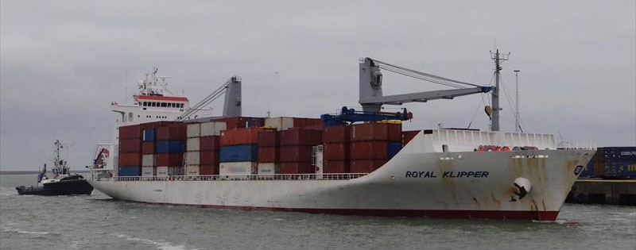



**SISTER SHIP:** COOL ROYAL / IMO9172959 / Built 2000

**General**

|  |  |
| --- | --- |
| Built | 2000 |
| Flag | Bahamas |
| Port of Registry | Bahamas |
| Call sign | C6FE3 |
| IMO/Lloyds nr | 9167801 |
| Length over all [m] | 155 |
| Beam[m] | 24 |
| Depth [m] | 13.8 |
| Bow thruster | Available |

|  |  |  |  |  |  |  |
| --- | --- | --- | --- | --- | --- | --- |
|  | | GT | | | NT | |
| International | | 11,382.00 | | | 6,408.00 | |
| Panama canal | |  | | | 10,045.00 | |
| Suez GRT/NRT | |  | 10,107.81 | | | |
|  | Draft | | | DWAT | |
| Summer | 10.12 m | | | 12902 t | |

**Reefer**

|  |  |
| --- | --- |
| Bale cbft | 580,754 |
| Area m2 | **6,613.0** |
| Hatch covers | 4 |
| Holds/Compartments | 4/19 |
| Cooling sections | 1UPDAB | 1C | 2UPDAB | 2CD | 3UPDAB | 3CD | 4UPDAB | 4CD |
| USDA | Sensors fitted |
| PPECB | Sensors fitted |
| Reefer plugs | 185 |
| Grating load | 9 MT Axleload pneumatic tires |
| Grating | Wooden |
| Temp min/max °C | -25/+15 |
| Air circs/hour | 90 |
| Air renew/hour | 4 |

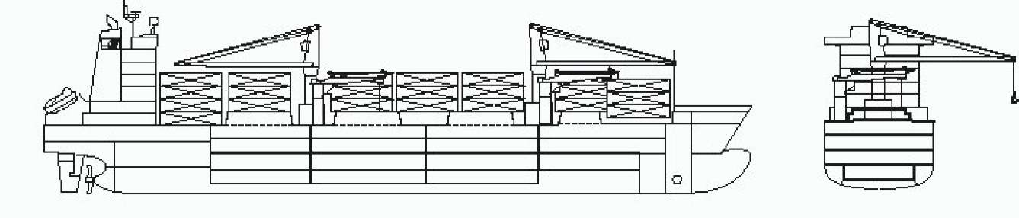

**Reefer Compartment Capacity Breakdown**

Bale capacity [cbft]

|  |  |  |  |  |
| --- | --- | --- | --- | --- |
| **DECK & HATCH** | **1** | **2** | **3** | **4** |
| **UPD** | 7,108 | 11,890 | 11,890 | 11,890 |
| **A** | 41,565 | 47,759 | 46,537 | 41,308 |
| **B** | 25,347 | 44,219 | 46,162 | 38,373 |
| **C** | 15,994 | 37,734 | 44,962 | 32,098 |
| **D** |  | 25,214 | 28,588 | 22,116 |
| **Total** | 90,014 | 166,816 | 178,139 | 145,785 |

Grand total 580,754 cbft

Deck area [m2]

|  |  |  |  |  |
| --- | --- | --- | --- | --- |
| DECK & HATCH | 1 | 2 | 3 | 4 |
| UPD | 86 | 144 | 144 | 144 |
| A | 420 | 532 | 517 | 469 |
| B | 290 | 500 | 522 | 437 |
| C | 191 | 436 | 516 | 368 |
| D |  | 300 | 338 | 259 |
| Total | 987 | 1,912 | 2,037 | 1,677 |

Grand total 6613 m2  
Free deckheight minimum 2.3 m

Hatch sizes [m]

|  |  |  |
| --- | --- | --- |
|  | Hold 1 | Hold 2,3,4 |
| Deck | 8.0 x 10.6 | 13.5 x 10.6 |
| UPD | 8.0 x 10.6 | 12.8 x 10.6 |
| A | 8.0 x 10.6 | 12.8 x 10.6 |
| B | 8.0 x 8.0 | 12.8 x 10.6 |
| C |  | 12.8 x 10.60 |

**CARGO GEAR**

|  |
| --- |
| 2 Cranes x 40.0 mt  2 Pallet Cranes x 8.0 mt  1 Container spreader 40ft x 0.0 mt  1 Container spreader 20ft x 0.0 mt |

|  |  |  |  |  |  |
| --- | --- | --- | --- | --- | --- |
| Container Carrying Capacity |  | Max FEU's | Add. TEU's | Max TEU's | Add. FEU's |
| **On Weather Deck and Hatches** |  |  |  |  |  |
| Empty Positions | Standard | 207 | 0 | 390 | 0 |
| Max Stackweight | Standard | 180 | 0 | 240 | 60 |
| Max Stackweight - Selfsustained | Standard | 180 | 0 | 240 | 60 |
| Empty Positions | High Cube | 207 | 0 | 390 | 0 |
| Max Stackweight | High Cube | 180 | 0 | 240 | 60 |
| Max Stackweight - Selfsustained | High Cube | 180 | 0 | 240 | 60 |
| **Reefer Hold** |  |  |  |  |  |
| Empty Positions | Standard | 60 | 2 | 132 | 0 |
| Max Stackweight | Standard | 60 | 2 | 132 | 0 |
| Max Stackweight - Selfsustained | Standard | 60 | 2 | 132 | 0 |
| Empty Positions | High Cube | 60 | 2 | 132 | 0 |
| Max Stackweight - Selfsustained | High Cube | 60 | 2 | 132 | 0 |

**Reefer plugs: 185**

*Particulars are given without guarantee and do not form part of any Charter Party agreement*