**COOL EXPLORER**

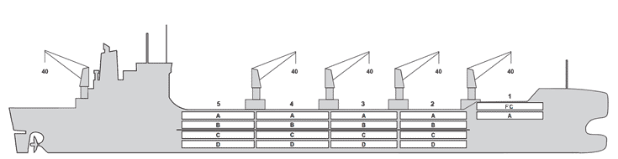

**BASICS**

|  |  |
| --- | --- |
| Flag | Panama |
| LLoyds no. | 9836880 |
| Class | NK |
| Int GRT/NRT | 22,452 / 9,657 |
| Pan GRT/NRT | 18,709 |
| Suez GRT/NRT | 23,272 /19,361 |
| Built | 2019 |
| Length over all m | 189.90 |
| Breadth moulded m | 30.70 |
| Depth W.D. m | 15.5 |
| Sdwt mton | 23,169 |
| Draught sdwt m | 10.33 |
| Bale cbft | 904,950 |
| Area m2 | 9,672 |
| Bow thruster | Available |
| Hatch covers | 5 |
| Holds/Compartments | 5 / 18 |
| Fcsle deck | YES |
| Trunk deck | NO |
| USDA | Sensors fitted |
| PPECB | Sensors fitted |
| Reefer plugs | 342 |
| Grating load | 7 MT Axleload |
|  | Pneumatic tires |
| Grating | Aluminium |
| Temp min/max °C | -30 / 15 |
| Air circs/hour | 90 |
| Air renew/hour | 2.5 |
|  |  |

**BALE cbft**

|  |  |  |  |  |  |
| --- | --- | --- | --- | --- | --- |
| DECK & HATCH | 1 | 2 | 3 | 4 | 5 |
| FC | 34,542 |  |  |  |  |
| A | 17,301 | 56,801 | 72,410 | 72,445 | 65,494 |
| B |  | 35,891 | 61,515 | 65,644 | 58,732 |
| C |  | 28,778 | 56,140 | 65,442 | 58,157 |
| D |  | 20,596 | 46,167 | 38,398 | 50,497 |
| Total | 51,843 | 142,066 | 236,232 | 241,929 | 232,880 |

Grand total 904,950

**DECK AREA m2**

|  |  |  |  |  |  |
| --- | --- | --- | --- | --- | --- |
| DECK & HATCH | 1 | 2 | 3 | 4 | 5 |
| FC | 351 |  |  |  |  |
| A | 179 | 554 | 727 | 727 | 645 |
| B |  | 396 | 683 | 729 | 647 |
| C |  | 316 | 622 | 725 | 639 |
| D |  | 229 | 515 | 427 | 561 |
| Total | 530 | 1,495 | 2,547 | 2,608 | 2,492 |

Grand total 9,672

Free deckheight minimum 2.50 m

**HATCHES (Weather deck) m**

|  |  |  |  |
| --- | --- | --- | --- |
| Hatch | Length | Width | Insulated units |
| 1 | 6.65 | 10.3 | 1F/A |
| 2 | 12.6 | 10.3 | AB/CD |
| 3 | 12.6 | 10.3 | AB/CD |
| 4 | 12.6 | 10.3 | AB/CD |
| 5 | 12.6 | 10.3 | AB/CD |

Insulated units are separate cooling sections.

**COOL EXPLORER**

**CARGO GEAR**

|  |  |  |  |
| --- | --- | --- | --- |
| No of | Type | SWL mton | UP mton |
| 5 | Electro hydraulic | 40 | - |

Max single lift cap: 5 x 40 MT

Max twin lift cap : 40MT

**MAXIMUM CONTAINER CAPACITY**

|  |  |  |  |
| --- | --- | --- | --- |
|  | 20 ft (8'6'') Empty/ loaded | 40 ft (9'6'') Empty/ loaded | Stackweight 20 ft/ 40 ft |
| Weather Deck | 312/ 312 | 254/ 254 | 60,0 / 124,0 |
| Hatch covers | 132 / 132 | 88 / 88 | 50,0 / 124,0 |
| Holds | 120 / 120 | 58 / 58 | 80,0 / 124,0 |

Reefer plugs: 342

Above figures based on 14 M for loaded 20 ft and 25 MT for loaded 40 ft Subject Master approval, Stability & Visibility

Please contact Cool Carriers Ltd for information about speed and consumption

All details believed to be correct but not guaranteed