 **COOL SPIRIT**

653,310 cbft / 7290,7 sqm /built 2018

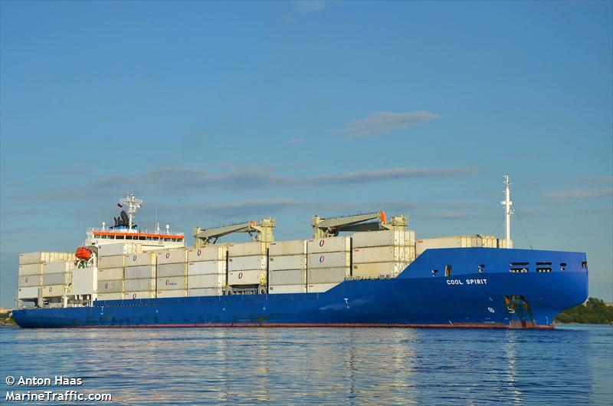

**SISTER SHIPS:**

BALTIC SPIRITIMO 9765873 / Built 2018

**General**

|  |  |
| --- | --- |
| Built | 2018 |
| Flag | Bahamas |
| Port of Registry | Bahamas |
| Call sign | C6EC2 |
| IMO/Lloyds nr | 9765861 |
| Length over all [m] | 188,6 |
| Beam[m] | 26 |
| Depth [m] | 14,1 |
| Bow thruster | 1010 KW |

|  |  |  |
| --- | --- | --- |
|  | **GT** | **NT** |
| **International** | 17,421 | 8,092 |
| **Panama canal** | | 8092 |
| **Suez GRT/NRT** | 18’038 | 14’827 |
|  |  |  |
|  | **Draft** | **DWAT** |
| **Tropical** | 9,922 | 17399 |
| **Summer** | 9,72 | 16727 |
| **Winter** | 9,518 | 15780 |

**Reefer**

|  |  |
| --- | --- |
| Bale cbft | 653,31 |
| Area m2 | **7290,7** |
| Hatch covers | 5 |
| Holds/Compartments | 4/15+container hold № 3 |
| Cooling sections | 1A/BC,2,4,5AB/CD |
| Fcsle deck | NO |
| Trunk deck | NO |
| USDA | Sensors fitted |
| PPECB | Sensors fitted |
| Reefer plugs | 320 |
| Grating load | 7 MT Axleload pneumatic tires |
| Grating | Wood |
| Temp min/max °C | -30/+15 |
| Air circs/hour | 90 |
| Air renew/hour | 2 |

**COOL SPIRIT**

653,310 cbft / 7290,7 sqm /built 2018

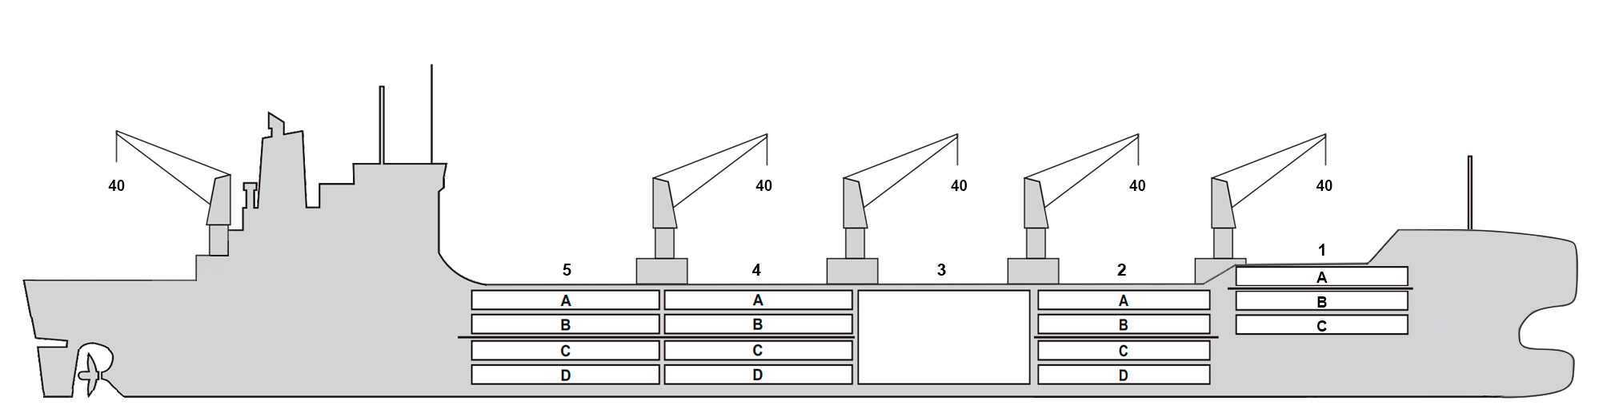

**Reefer Compartment Capacity Breakdown**

Bale capacity [cbft]

|  |  |  |  |  |
| --- | --- | --- | --- | --- |
| DECK & HATCH | 1 | 2 | 3 | 4 |
| FC | 52301 |  |  |  |
| A | 29262 | 55000 | 54993 | 55314 |
| B | 16842 | 43232 | 52167 | 50514 |
| C |  | 37550 | 51631 | 44052 |
| D |  | 30530 | 41891 | 41891 |
| Total | 98405 | 166312 | 200682 | 200682 |

Grand total 653,310 cbft

Deck area [m2]

|  |  |  |  |  |
| --- | --- | --- | --- | --- |
| DECK & HATCH | 1 | 2 | 3 | 4 |
| FC | 551.7 |  |  |  |
| A | 311.2 | 570.4 | 573.5 | 574.9 |
| B | 193.3 | 490.6 | 619.9 | 571.4 |
| C |  | 440.2 | 618.7 | 525.7 |
| D |  | 349.7 | 470.5 | 429 |
| Total | 1056.2 | 1850.9 | 2282.6 | 2101 |

Grand total 7290,7 m2

Free deckheight minimum 2.30 m

Hatch sizes [m]

|  |  |  |  |
| --- | --- | --- | --- |
| Hatch | Length | Width | Insulated units |
| 1 | 12,6 | 10,3 | A/BC |
| 2 | 12,6 | 10,3 | AB/CD |
| 3 | 12,6 | 21,4 |  |
| 4 | 12,3 | 10,3 | AB/CD |
| 5 | 12,6 | 10,3 | AB/CD |

CARGO GEAR

|  |  |  |  |
| --- | --- | --- | --- |
| No | Type | SWL mton | UP mton |
| 5 | Electro hydraulic | 40 | - |

Max single lift cap: 5*40 MT

Max twin lift cap: 40MT

MAXIMUM CONTAINER CAPACITY

|  |  |  |  |
| --- | --- | --- | --- |
|  | 20 ft (8'6'') Empty/ loaded | 40 ft (9'6'') Empty/ loaded | Stackweight 20 ft/ 40 ft |
| Weather Deck | 216/169 | 187/ 152 | 48,60,96/90,100,120 |
| Hatch covers | 188/126 | 106/91 | 24,48,50/63.5 - 108 |
| Holds | 182 / 182 | 91/91 | 45,80,94.5/35-150 |

Reefer plugs: 320

*Above figures based on 14 M for loaded 20 ft and 30 MT for loaded 40 ft. Actual container intake is subject to master’s approval and depending on stability, stackweight and visibility.*