 **CROWN GARNET**

547,693 cbft / 6,226 sqm/ Built 1996

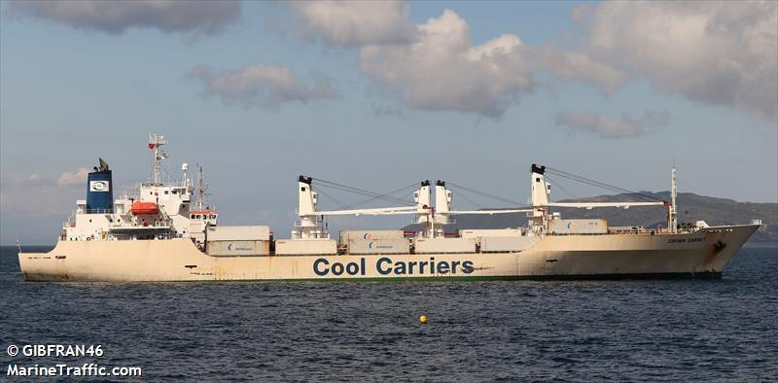

**SISTER SHIPS**:

CROWN RUBY  
 IMO 9159103 / Built 1996

CROWN JADE

IMO 9128051 / Built 1997

CROWN OPAL

IMO 9128063 / Built 1997

CROWN SAPPHIRE

IMO 9159115 / Built 1997

CROWN TOPAZ  
IMO 9191498 / Built 1999

**General**

|  |  |
| --- | --- |
| Built | December -1996 |
| Flag | Bahamas |
| Port of Registry | Bahamas |
| Call sign | C6DT9 |
| IMO/Lloyds nr | 9128049 |
| Length over all [m] | 151,99 |
| Beam[m] | 23 |
| Depth [m] | 13 |
| Bow thruster | N/A |

|  |  |  |
| --- | --- | --- |
|  | GT | NT |
| International | 10519 | 5406 |
| Panama canal |  | 8863 |
| Suez GRT/NRT | 11433 | 9350 |

|  |  |  |
| --- | --- | --- |
|  | Draft | DWAT |
| Tropical | 8,848 | 10784 |
| Summer | 8,668 | 10332 |
| Winter | 8,488 | 9887 |

**Reefer**

|  |  |
| --- | --- |
| Bale cbft | 547,693 |
| Area m2 | **6,226** |
| Hatch covers | 4 |
| Holds/Compartments | 4/16 |
| Cooling sections | 1A/BCD, 2AB/CD, 3AB/CD,4AB/CD |
| Fcsle deck | YES |
| Trunk deck | NO |
| USDA | Sensors fitted |
| PPECB | Sensors fitted |
| Reefer plugs | 70 |
| Grating load | 6 MT Axleload pneumatic tires |
| Grating | Wood |
| Temp min/max °C | -30/32 |
| Air circs/hour | 90 |
| Air renew/hour | 4 |

 **CROWN GARNET**

547,693 cbft / 6,226 sqm/ Built 1996

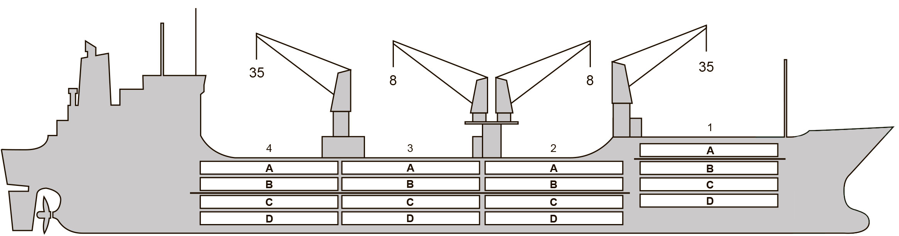

**Reefer Compartment Capacity Breakdown**

Bale capacity [cbft]

Grand total 547,693cbft

|  |  |  |  |  |
| --- | --- | --- | --- | --- |
| DECK & HATCH | 1 | 2 | 3 | 4 |
| FC |  |  |  |  |
| A | 45,136 | 43,584 | 45,014 | 44,832 |
| B | 25,952 | 37,443 | 39,973 | 39,641 |
| C | 20,087 | 30,972 | 38,621 | 34,924 |
| D | 8,612 | 26,150 | 37,113 | 29,639 |
| Total | 99,787 | 138,149 | 160,721 | 149,036 |

Deck area [m2]

|  |  |  |  |  |
| --- | --- | --- | --- | --- |
| DECK & HATCH | 1 | 2 | 3 | 4 |
| FC |  |  |  |  |
| A | 489 | 460 | 476 | 475 |
| B | 304 | 436 | 481 | 475 |
| C | 213 | 381 | 475 | 434 |
| D | 107 | 281 | 432 | 307 |
| Total | 1,113 | 1,558 | 1,864 | 1,691 |

Grand total 6,226 m2

Free deckheight minimum 2.20 m

Hatch sizes [m]

|  |  |  |  |
| --- | --- | --- | --- |
| Hatch | Length | Width | Insulated units |
| 1 | 13.0 | 7.8 | A/BCD |
| 2 | 13.0 | 7.8 | AB/CD |
| 3 | 13.0 | 7.8 | AB/CD |
| 4 | 13.0 | 7.8 | AB/CD |

CARGO GEAR

|  |  |  |  |
| --- | --- | --- | --- |
| No of | Type | SWL mton | UP mton |
| 2 | Electro hydraulic | 35 | - |
| 2 | Electro hydraulic | 8 | - |

Max single lift cap: 2 x 35 MT / 2 x 8 MT

Max twin lift cap : N/A

MAXIMUM CONTAINER CAPACITY

|  |  |  |  |
| --- | --- | --- | --- |
|  | 20 ft (8'6'') Empty/ loaded | 40 ft (9'6'') Empty/ loaded | Stackweight 20 ft/ 40 ft |
| Weather Deck | 132 / 92 | 64 / 46 | 48 / 60 |
| Hatch covers | 64 / 48 | 32 / 24 | 48 / 60 |
| Holds | 72 / 54 | 36 / 18 | 72 / 120 |

Reefer plugs: 70

*Above figures based on 14 MT for loaded 20 ft and 30 MT for loaded 40 ft. Actual container intake is subject to master’s approval and depending on stability, stackweight and visibility.*