**Crown Ruby**

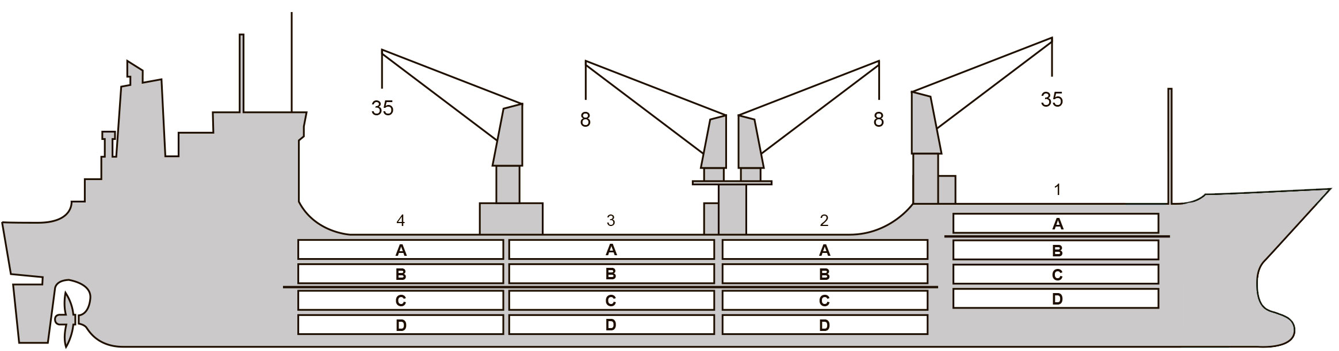

**BASICS**

|  |  |
| --- | --- |
| Flag | Bahamas |
| LLoyds no. | 9159103 |
| Class | RINA |
| Int GRT/NRT | 10,519 / 5,406 |
| Pan GRT/NRT | 10,519 / 8,862 |
| Suez GRT/NRT | 11,433 / 9,350 |
| Built | 1 996 |
| Length over all m | 151.99 |
| Breadth moulded m | 23.0 |
| Depth W.D. m | 13.0 |
| Sdwt mton | 10,332 |
| Draught sdwt m | 8.7 |
| Bale cbft | 547,600 |
| Area m2 | 6,190 |
| Bow thruster | N/A |
| Hatch covers | 4 |
| Holds/Compartmens | 4/16 |
| Fcsle deck | YES |
| Trunk deck | NO |
| USDA | Sensors fitted |
| PPECB | Sensors fitted |
| Reefer plugs | 70 |
| Grating load | 6 MT Axleload |
|  | Pneumatic tires |
| Grating | Wood |
| Temp min/max °C | -30 / 32 |
| Air circs/hour | 90 |
| Air renew/hour | 4 |
|  |  |

**BALE cbft**

|  |  |  |  |  |
| --- | --- | --- | --- | --- |
| DECK & HATCH | 1 | 2 | 3 | 4 |
| FC |  |  |  |  |
| A | 45,127 | 43,540 | 44,929 | 44,747 |
| B | 25,886 | 37,594 | 39,920 | 39,597 |
| C | 20,242 | 30,832 | 38,656 | 34,977 |
| D | 8,614 | 26,089 | 37,181 | 29,669 |
| Total | 99,869 | 138,055 | 160,686 | 148,990 |

Grand total 547,600

**DECK AREA m2**

|  |  |  |  |  |
| --- | --- | --- | --- | --- |
| DECK & HATCH | 1 | 2 | 3 | 4 |
| FC |  |  |  |  |
| A | 448 | 461 | 477 | 475 |
| B | 308 | 438 | 480 | 474 |
| C | 215 | 379 | 475 | 433 |
| D | 105 | 280 | 432 | 308 |
| Total | 1,077 | 1,558 | 1,865 | 1,690 |

Grand total 6,190

Free deckheight minimum 2.20 m

**HATCHES (Weather deck) m**

|  |  |  |  |
| --- | --- | --- | --- |
| Hatch | Length | Width | Insulated units |
|  |  |  |  |
| 1 | 13.0 | 7.8 | A/BCD |
| 2 | 13.0 | 7.8 | AB/CD |
| 3 | 13.0 | 7.8 | AB/CD |
| 4 | 13.0 | 7.8 | AB/CD |

Insulated units are separate cooling sections.

**Crown Ruby**

**CARGO GEAR**

|  |  |  |  |
| --- | --- | --- | --- |
| No of | Type | SWL mton | UP mton |
| 2 | Electro hydraulic | 35 | - |
| 2 | Electro hydraulic | 8 | - |

Max single lift cap: 2 x 35 MT / 2 x 8 MT

Max twin lift cap : N/A

**MAXIMUM CONTAINER CAPACITY**

|  |  |  |  |
| --- | --- | --- | --- |
|  | 20 ft (8'6'') Empty/ loaded | 40 ft (9'6'') Empty/ loaded | Stackweight 20 ft/ 40 ft |
| Weather Deck | 132 / 92 | 64 / 46 | 48 / 60 |
| Hatch covers | 64 / 48 | 32 / 24 | 48 / 60 |
| Holds | 72 / 54 | 36 / 36 | 72 / 120 |

Reefer plugs: 70

Above figures based on 14 MT for loaded 20 ft and 30 MT for loaded 40 ft Subject Master approval, Stability & Visibility

Please contact Cool Carriers for information about speed and consumption

All details believed to be correct but not guaranteed