**Crown Topaz**

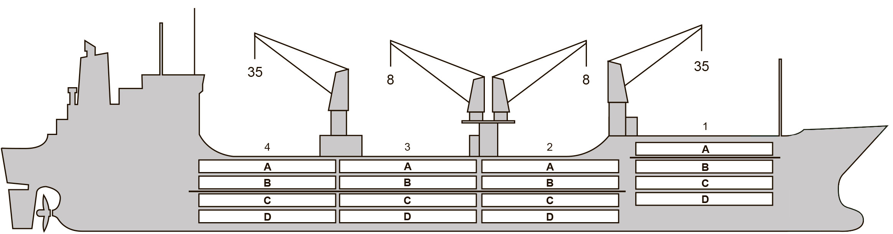

**BASICS**

|  |  |
| --- | --- |
| Flag | Bahamas |
| LLoyds no. | 9191498 |
| Class | RINA |
| Int GRT/NRT | 10,527 / 5,406 |
| Pan GRT/NRT | - / 8,869 |
| Suez GRT/NRT | 11,427 / 9,329 |
| Built | 1 999 |
| Length over all m | 151.99 |
| Breadth moulded m | 23.0 |
| Depth W.D. m | 13.0 |
| Sdwt mton | 10,318 |
| Draught sdwt m | 8.7 |
| Bale cbft | 547,693 |
| Area m2 | 6,226 |
| Bow thruster | N/A |
| Hatch covers | 4 |
| Holds/Compartmens | 4/16 |
| Fcsle deck | YES |
| Trunk deck | NO |
| USDA | Sensors fitted |
| PPECB | Sensors fitted |
| Reefer plugs | 68 |
| Grating load | 6 MT Axleload |
|  | Pneumatic tires |
| Grating | Wood |
| Temp min/max °C | -30 / 32 |
| Air circs/hour | 90 |
| Air renew/hour | 4 |
|  |  |

**BALE cbft**

|  |  |  |  |  |
| --- | --- | --- | --- | --- |
| DECK & HATCH | 1 | 2 | 3 | 4 |
| FC |  |  |  |  |
| A | 45,136 | 43,584 | 45,014 | 44,832 |
| B | 25,952 | 37,443 | 39,973 | 39,641 |
| C | 20,087 | 30,972 | 38,621 | 34,924 |
| D | 8,612 | 26,150 | 37,113 | 29,639 |
| Total | 99,787 | 138,149 | 160,721 | 149,036 |

Grand total 547,693

**DECK AREA m2**

|  |  |  |  |  |
| --- | --- | --- | --- | --- |
| DECK & HATCH | 1 | 2 | 3 | 4 |
| FC |  |  |  |  |
| A | 489 | 460 | 476 | 475 |
| B | 304 | 436 | 481 | 475 |
| C | 213 | 381 | 475 | 434 |
| D | 107 | 281 | 432 | 307 |
| Total | 1,113 | 1,558 | 1,864 | 1,691 |

Grand total 6,226

Free deckheight minimum 2.20 m

**HATCHES (Weather deck) m**

|  |  |  |  |
| --- | --- | --- | --- |
| Hatch | Length | Width | Insulated units |
|  |  |  |  |
| 1 | 13.0 | 7.8 | A/BCD |
| 2 | 13.0 | 7.8 | AB/CD |
| 3 | 13.0 | 7.8 | AB/CD |
| 4 | 13.0 | 7.8 | AB/CD |

Insulated units are separate cooling sections.

**Crown Topaz**

**CARGO GEAR**

|  |  |  |  |
| --- | --- | --- | --- |
| No of | Type | SWL mton | UP mton |
| 2 | Electro hydraulic | 35 | - |
| 2 | Electro hydraulic | 8 | - |

Max single lift cap: 2 x 35 MT / 2 x 8 MT

Max twin lift cap : N/A

**MAXIMUM CONTAINER CAPACITY**

|  |  |  |  |
| --- | --- | --- | --- |
|  | 20 ft (8'6'') Empty/ loaded | 40 ft (9'6'') Empty/ loaded | Stackweight 20 ft/ 40 ft |
| Weather Deck | 132 / 92 | 64 / 44 | 48 / 60 |
| Hatch covers | 64 / 48 | 32 / 24 | 48 / 60 |
| Holds | 72 / 54 | 36 / 36 | 72 / 120 |

Reefer plugs: 68

Above figures based on 14 MT for loaded 20 ft and 30 MT for loaded 40 ft Subject Master approval, Stability & Visibility

Please contact Cool Carriers for information about speed and consumption

All details believed to be correct but not guaranteed