 **CS STRATOS**

617,571 cbft / 6,878.2 sqm / Built 2007

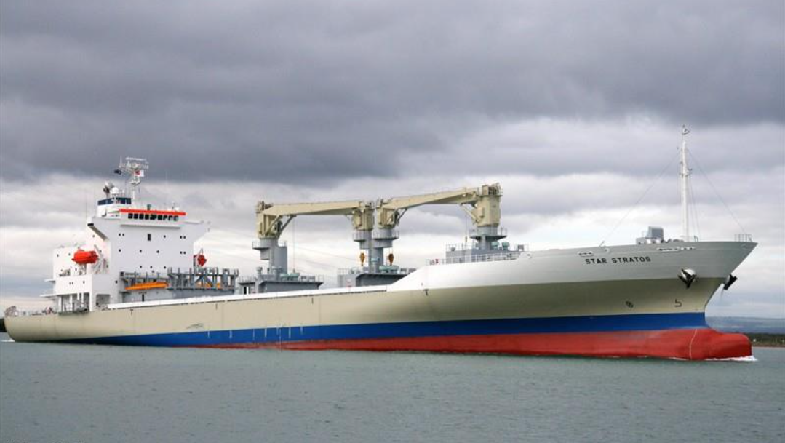

**General**

|  |  |  |  |  |  |
| --- | --- | --- | --- | --- | --- |
| **Built** | **May – 2007** |  |  | **GT** | **NT** |
| **Flag** | Singapore |  | **International** | 14,284.0 | 6724 |
| **Port of Registry** | Singapore |  | **Panama canal** | 14,284.0 | 12,244.0 |
| **Call sign** | 9V9356 |  | **Suez GRT/NRT** | 14,867.75 | 12,312.94 |
| **IMO/Lloyds nr** | 9350991 |  |  |  |  |
| **Length over all [m]** | 162,5 |  |  | **Draft** | **DWAT** |
| **Beam[m]** | 26 |  | **Tropical** | 9,922 | 13,863 |
| **Depth [m]** | 14,1 |  | **Summer** | 9,720 | 13,186 |
| **Bow thruster** | 800 KW / 1000HP |  | **Winter** | 9,518 | 12,528 |
| **Fresh Water** | 9.887 |  | **Tropical FW** | 10,089 | 13,866 |

**Reefer**

|  |  |
| --- | --- |
| Bale cbft | 617,571 |
| Area m2 | **6,878.2** |
| Hatch covers | 4 |
| Holds/Compartments | 4/15 |
| Cooling sections | 1F/AB,2AB/CD,3AB/CD,4AB/CD |
| Fcsle deck | YES |
| Trunk deck | NO |
| USDA | Sensors fitted |
| PPECB | Sensors fitted |
| Reefer plugs | 200 |
| Grating load | 6 MT Axle load with pneumatic rubber tires |
| Grating | Wood |
| Temp min/max °C | -25/+15 |
| Air circs/hour | 90 |
| Air renew/hour | 2 |
| Clear deck height | 2.30 m |

 **CS STRATOS**

617,571 cbft / 6,878.2 sqm / Built 2007

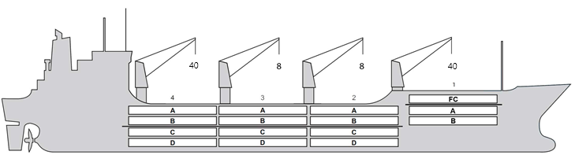

**Reefer Compartment Capacity Breakdown**

Bale capacity [cbft]

|  |  |  |  |  |
| --- | --- | --- | --- | --- |
| DECK & HATCH | 1 | 2 | 3 | 4 |
| FC | 55931 |  |  |  |
| A | 30374 | 54028 | 54159 | 52460 |
| B | 18455 | 43557 | 49557 | 45499 |
| C |  | 37190 | 45927 | 37253 |
| D |  | 30586 | 33842 | 28753 |
| Total | 104760 | 165361 | 183485 | 163965 |

Grandtotal 617,571 cbft

Deck area [m2]

|  |  |  |  |  |
| --- | --- | --- | --- | --- |
| DECK & HATCH | 1 | 2 | 3 | 4 |
| FC | 590.6 |  |  |  |
| A | 325.9 | 558.9 | 561.2 | 541.1 |
| B | 212.4 | 495.4 | 562.9 | 517.3 |
| C |  | 444.2 | 550.0 | 444.9 |
| D |  | 351.6 | 390.2 | 331.6 |
| Total | 1128.9 | 1850.1 | 2064.3 | 1834.9 |

Grand total 6878.2 m2

Cargo space volume is including the hatch way volume

Hatch sizes [m]

|  |  |  |  |
| --- | --- | --- | --- |
| Hatch | Length | Width | Insulated units |
| 1 | 12.6/9.6 | 10.3/6.0 | FC/AB |
| 2 | 12.6 | 10,3 | AB/CD |
| 3 | 12.6 | 10,3 | AB/CD |
| 4 | 12.3 | 10,3 | AB/CD |

CARGO GEAR

|  |  |  |  |
| --- | --- | --- | --- |
| No | Type | SWL mton | UP mton |
| 1,4 | hydraulic | 40 | - |
| 2,3 | hydraulic | 8 | - |

Max single lift cap: N/A

Max twin lift cap: N/A

MAXIMUM CONTAINER CAPACITY

|  |  |  |  |  |
| --- | --- | --- | --- | --- |
|  | 20 ft (8'6'') | 40 ft (8'6'') | 40 ft (9'6'') | Stackweight 20 ft/ 40 ft |
| WeatherDeck | 184 | 150 | 150 | 60 / 60,90,108 |
| Hatchcovers | 140 | 70 | 70 | 40,50 / 60,108 |
| Holds | 112 | 56 | 56 | 45,25,80 / 60,35,120 |

Reefer plugs: 200

*Note: Maximum Reefer container capacity is approx. FEU at 27 MT for loaded 40 ft. Maximum container load for particular voyage is subject to Stability, Stack weight limitations, Visibility from bridge and masters approval.*