 **DITLEV REEFER**

758,725 cbft / 9,010 sqm / Built 1990

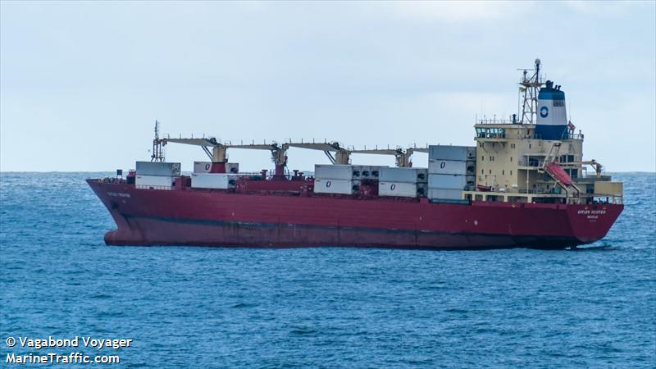

**SISTER SHIPS:**

KNUD REEFER  
IMO 8903167 / Built 1991

IVAR REEFER   
IMO 8819938 / Built 1990

JORGEN REEFER

IMO 9007489 / Built 1991

**General**

|  |  |
| --- | --- |
| Built | 1990 |
| Flag | Panama |
| Port of Registry | Panama |
| Call sign | C6ZP7 |
| IMO/Lloyds nr | 8819926 |
| Length over all [m] | 164,33 |
| Beam[m] | 24 |
| Depth [m] | 15,7 |
| Bow thruster | yes, and stern thruster |

|  |  |  |
| --- | --- | --- |
|  | GT | NT |
| International | 14,406 | 6,673 |
| Panama canal | 15,481 | 12,018 |
| Suez GRT/NRT | 15,225 | 12,234 |

|  |  |  |
| --- | --- | --- |
|  | Draft | DWAT |
| Tropical | 10,223 | 17618 |
| Summer | 10,015 | 16950 |
| Winter | 9,807 | 16284 |

**Reefer**

|  |  |
| --- | --- |
| Bale cbft | 758,725 |
| Area m2 | **9,010** |
| Hatch covers | 9 |
| Holds/Compartments | 5/23 |
| Cooling sections | 1AB/C, 2345AB/CD |
| Fcsle deck | NO |
| Trunk deck | NO |
| USDA | Sensors fitted |
| PPECB | Sensors fitted |
| Reefer plugs | 184 |
| Grating load | 7 MT Axleload pneumatic tires |
| Grating | Aluminium |
| Temp min/max °C | -29/15 |
| Air circs/hour | 90 |
| Air renew/hour | 4 |

 **DITLEV REEFER**

758,725 cbft / 9,010 sqm / Built 1990

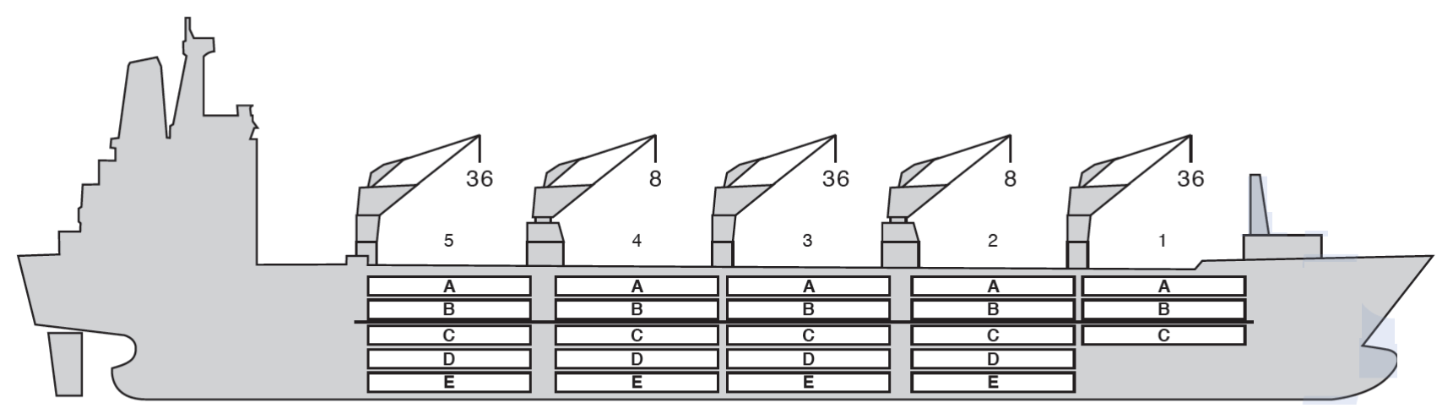

**Reefer Compartment Capacity Breakdown**

Bale capacity [cbft]

Grand total 758,825 cbft

|  |  |  |  |  |  |
| --- | --- | --- | --- | --- | --- |
| DECK & HATCH | 1 | 2 | 3 | 4 | 5 |
| A | 37,858 | 33,895 | 34,548 | 34,87 | 34,973 |
| B | 28,81 | 32,988 | 34,319 | 34,326 | 34,174 |
| C | 20,288 | 30,855 | 34,87 | 34,87 | 35,428 |
| D |  | 28,037 | 34,344 | 35,538 | 34,196 |
| E |  | 19,19 | 28,164 | 28,446 | 22,686 |
| Total | 90,968 | 151,625 | 173,305 | 174,71 | 168,117 |

Deck area [m2]

|  |  |  |  |  |  |
| --- | --- | --- | --- | --- | --- |
|  | 1 | 2 | 3 | 4 | 5 |
| A | 423 (1.8) | 420 (1.8) | 440 (1.8) | 439 (1.8) | 440 (1.8) |
| B | 327 (1.8) | 391 (1.8) | 420 (1.8) | 424 (1.8) | 425 (1.8) |
| C | 221 (1.8) | 369 (1.8) | 439 (1.8) | 439 (1.8) | 436 (1.8) |
| D |  | 338 (1.8) | 429 (1.8) | 439 (1.8) | 496 (1.8) |
| E |  | 224 (1.8) | 360 (1.8) | 355 (1.8) | 278 (1.8) |
| Total | 961 | 1,742 | 2,088 | 2,096 | 1,975 |

Grand total 9,010 sqm

Free deckheight minimum 2.20 m

|  |  |  |  |
| --- | --- | --- | --- |
| Hatch sizes [m] | |  |  |
| **Hatch** | **Length** | **Width** | **Insulated units** |
| **1** | 13,4 | 10,6 | ABC |
| **2** | 2 x 13.4 | 8,8 | AB/CDE |
| **3** | 2 x 13.4 | 8,8 | AB/CDE |
| **4** | 2 x 13.4 | 8,8 | AB/CDE |
| **5** | 2 x 13.4 | 8,8 | AB/CDE |

|  |  |  |  |
| --- | --- | --- | --- |
| CARGO GEAR | |  |  |
| **No of** | **Type** | **SWL mton** | **UP mton** |
| **2** | Electro hydraulic | 36 / 8 | - |
| **2** | Electro hydraulic | 8 | - |
| Max single lift cap: | 2 x 8 MT / 3 x 36 MT | |  |
| Max twin lift cap : | - |  |  |

MAXIMUM CONTAINER CAPACITY

|  |  |  |  |
| --- | --- | --- | --- |
|  | 20 ft (8’6’’) Empty/ loaded | 40 ft (9’6’’) Empty/ loaded | Stackweight 20 ft/ 40 ft |
| Weather Deck | 60 / 40 | 24 / 16 | 28 - 42 / 65 - 75 |
| Hatch covers | 220 / 144 | 110 / 74 | 28 - 42 / 65 - 75 |
| Holds | 236 / 236 | 82 / 82 | 42 - 105 / 155 |

Reefer plugs: 184

*Above figures based on 14 MT for loaded 20 ft and 30 MT for loaded 40 ft. Actual container intake is subject to master’s approval and depending on stability, stackweight and visibility.*