**ICE GLACIER**

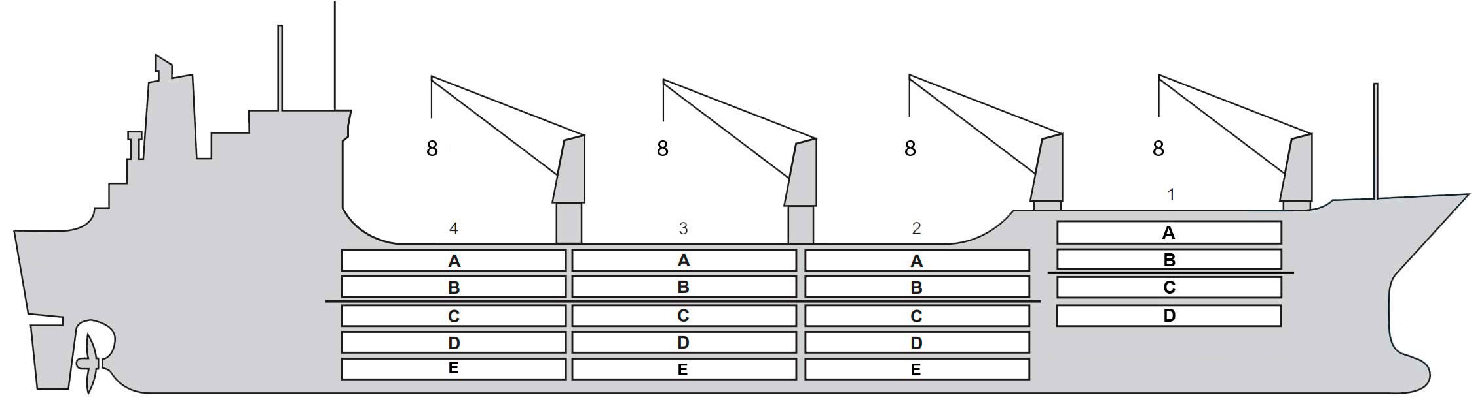

**BASICS**

|  |  |
| --- | --- |
| Flag | Bahamas |
| IMO no. | 8706789 |
| Class | Lloyd’s Register |
| Int GRT/NRT | 12,348 / 7,984 |
| Pan GRT/NRT | 14,078.79 / 11,239.87 |
| Suez GRT/NRT | 13,456.49 / 10,989.21 |
| Built | 1988 |
| Length over all m | 144.60 |
| Breadth moulded m | 23.60 |
| Depth W.D. m | 12.59 |
| Sdwt mton | 14,932 |
| Draught sdwt m | 10.025 |
| Bale cbft | 703,263 |
| Area m2 | 7,806 |
| Bow thruster | N/A |
| Hatch covers | 4 |
| Holds/Compartmens | 4 / 19 |
| Fcsle deck | NO |
| Trunk deck | NO |
| USDA | Sensors fitted |
| PPECB | N/A |
| Reefer plugs | 70 |
| Grating load | 6 MT max inc. cargo |
|  | Pneumatic tyres |
| Grating | Aluminium |
| Temp min/max °C | -25 / 13 |
| Air circs/hour | 90 |
| Air renew/hour | 2 |
|  |  |

**BALE cbft**

|  |  |  |  |  |
| --- | --- | --- | --- | --- |
| DECK & HATCH | 1 | 2 | 3 | 4 |
| A | 46,475 | 42,413 | 42,166 | 44,003 |
| B | 37,151 | 37,822 | 37,752 | 39,482 |
| C | 29,947 | 36,374 | 36,586 | 38,176 |
| D | 21,154 | 35,456 | 37,611 | 38,493 |
| E | N/A | 30,618 | 37,116 | 34,468 |
| Total | 134,727 | 182,683 | 191,231 | 194,622 |

Grand total 703,263

**DECK AREA m2**

|  |  |  |  |  |
| --- | --- | --- | --- | --- |
| DECK & HATCH | 1 | 2 | 3 | 4 |
| A | 459 | 443 | 440 | 460 |
| B | 403 | 444 | 444 | 465 |
| C | 325 | 435 | 446 | 465 |
| D | 211 | 401 | 444 | 441 |
| E | N/A | 305 | 422 | 353 |
| Total | 1,398 | 2,028 | 2,196 | 2,184 |

Grand total 7,806

Free deck height minimum 2.20 m

**HATCHES (Weather deck) m**

|  |  |  |  |
| --- | --- | --- | --- |
| Hatch | Length | Width | Insulated units |
| 1 | 9.1 | 7.7 | AB/CD |
| 2 | 9.1 | 7.7 | AB/CDE |
| 3 | 9.1 | 7.7 | AB/CDE |
| 4 | 9.1 | 7.7 | AB/CDE |

Insulated units are separate cooling sections.

**ICE GLACIER**

**CARGO GEAR**

|  |  |  |  |
| --- | --- | --- | --- |
| No of | Type | SWL mton | UP mton |
| 4 | Electro hydraulic | 8 | - |

Max single lift cap: 4 x 8 MT

Max twin lift cap : N/A

**MAXIMUM CONTAINER CAPACITY**

|  |  |  |  |
| --- | --- | --- | --- |
|  | 20 ft (8'6'') Empty/ loaded | 40 ft (9'6'') Empty/ loaded | Stackweight (tons) 20 ft/ 40 ft |
| Weather Deck | 36 / 28 | 58 / 48 | 54 / 75 |
| Hatch covers | 42 / 42 | 21 / 21 | 18(HC N1); 36(HC N2,3,4) / 25(HC N1); 50 (HC N2,3,4) |
| Holds | N / A | N / A | N / A |

**NOTE:** For Panama Canal Transit Empty/loaded 58 FEUs due to visibility regulations.

Reefer plugs: 70

Above figures based on 18 MT for loaded 20 ft and 25 MT for loaded 40 ft Subject Master approval, Stability & Visibility

Please contact Cool Carriers for information about speed and consumption

All details believed to be correct but not guaranteed