**ICE RUNNER**

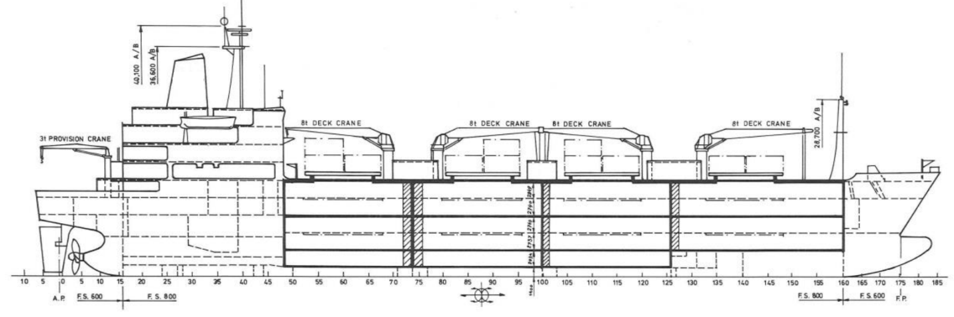

**BASICS**

|  |  |
| --- | --- |
| Flag | Bahamas |
| IMO No. | 8311120 |
| Class | Lloyd’s Register |
| Int GRT/NRT | 12,411 / 7,459 |
| Pan GRT/NRT | 14,003.21 / 10,891.34 |
| Suez GRT/NRT | 13,361.61 / 10,000.24 |
| Built | 1984 |
| Length over all m | 144.76 M |
| Breadth moulded m | 23.60 M |
| Depth moulded m | 15.40 |
| Sdwt mton | 14,530.4 |
| Draught sdwt m | 10.0 |
| Bale cbft | 668,187 |
| Area m2 | 7,704 |
| Bow thruster | N/A |
| Hatch covers | 4 |
| Holds/Compartmens | 4/19 |
| Fcsle deck | NO |
| Trunk deck | NO |
| USDA | Sensors fitted |
| PPECB | NO |
| Reefer plugs | 70 |
| Grating load | 7 MT Axleload |
|  | Pneumatic tires |
| Grating | Aluminium |
| Temp min/max °C | -25 / 35 |
| Air circs/hour | 90 |
| Air renew/hour | 2 for Bananas,  1 for Fruits & Vegetables,  0 for Frozen goods |
|  |  |

**BALE cbft**

|  |  |  |  |  |
| --- | --- | --- | --- | --- |
| DECK & HATCH | 1 | 2 | 3 | 4 |
| A | 44,500 | 38,178 | 38,394 | 38,297 |
| B | 38,043 | 36,373 | 36,508 | 36,250 |
| C | 30,796 | 34,342 | 35,032 | 34,836 |
| D | 23,960 | 34,093 | 36,239 | 35,924 |
| E |  | 29,023 | 35,324 | 32,075 |
| Total | 137,299 | 172,009 | 181,497 | 177,382 |

Grand total 668,187

**DECK AREA m2**

|  |  |  |  |  |
| --- | --- | --- | --- | --- |
| DECK & HATCH | 1 | 2 | 3 | 4 |
| A | 483 | 430 | 430 | 428 |
| B | 430 | 431 | 435 | 431 |
| C | 353 | 422 | 435 | 431 |
| D | 252 | 393 | 433 | 421 |
| E |  | 308 | 410 | 348 |
| Total | 1,518 | 1,984 | 2,143 | 2,059 |

Grand total 7,704

Free deckheight minimum 2.20 m

**HATCHES (Weather deck) m**

|  |  |  |  |
| --- | --- | --- | --- |
| Hatch | Length | Width | Insulated units |
| 1 | 9.1 | 7.7 | AB/CD |
| 2 | 9.1 | 7.7 | AB/CDE |
| 3 | 9.1 | 7.7 | AB/CDE |
| 4 | 9.1 | 7.7 | AB/CDE |

Insulated units are separate cooling sections.

**ICE RUNNER**

**CARGO GEAR**

|  |  |  |  |
| --- | --- | --- | --- |
| No of | Type | SWL mton | UP mton |
| 4 | Electro Hydraulic Single Crane | 8 | - |

Max single lift cap: 4 x 8 MT

Max twin lift cap : N/A

**MAXIMUM CONTAINER CAPACITY**

|  |  |  |  |  |  |
| --- | --- | --- | --- | --- | --- |
|  | 20 ft (8'6'') Empty/ loaded | 40 ft (9'6'') Empty/ loaded | Stackweight | 20 ft | 40 ft |
| Weather Deck | 121/121 | 40 / 36 | Weather Deck forward of FR133 | 39.0t | 65.0t |
| Weather Deck aft FR133 | 51.0t | 65.0t |
| Hatch covers | 27 / 27 | 13 / 12 | Weather Deck Hatch No1 | 19.5t | 32.5t |  |
| Weather Deck Hatch No2,3 and 4 | 39.0t | 32.5t |  |
| Holds | N / A | N / A | N / A | | |

Reefer plugs: 70

Above figures based on 14 MT for loaded 20 ft and 30 MT for loaded 40 ft Subject to Master’s approval, Stability & Visibility condition.

Please contact Cool Carriers for information about speed and consumption.

All details believed to be correct but not guaranteed.