**KNUD REEFER**

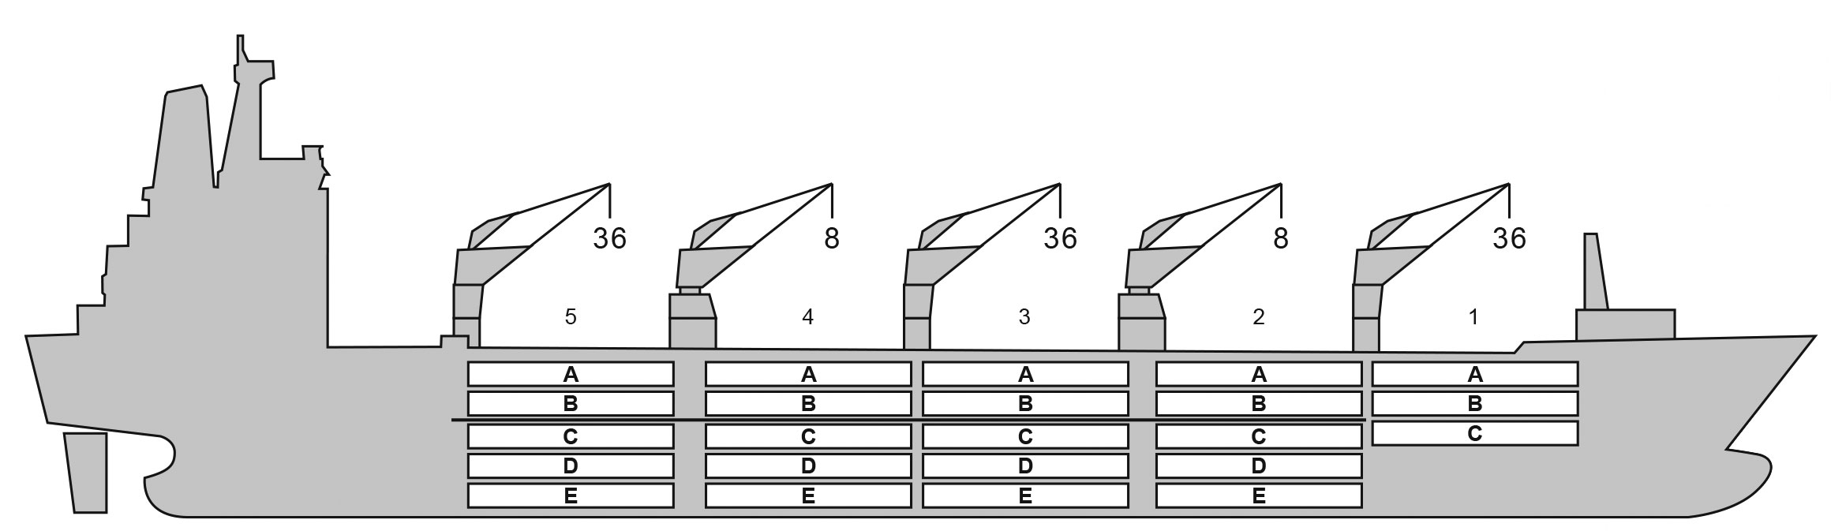

**BALE cbft**

**BASICS**

|  |  |  |  |  |  |
| --- | --- | --- | --- | --- | --- |
| **DECK & HATCH** | **1** | **2** | **3** | **4** | **5** |
| A | 37,858 | 33,895 | 34,548 | 34,870 | 34,973 |
| B | 28,810 | 32,988 | 34,319 | 34,326 | 34,174 |
| C | 20,288 | 30,855 | 34,870 | 34,870 | 35,428 |
| D | - | 28,037 | 34,344 | 35,538 | 34,196 |
| E | - | 19,190 | 28,164 | 28,846 | 22,686 |
| Total | 90,968 | 151,625 | 173,305 | 174,710 | 168,117 |
| Grand total | 758,725 |  | | | |

DECK AREA m2 and DECK STRENGTH MT/m2

Aluminium

-29 / 15

90

4

Grating

Temp min/max °C Air circs/hour

Air renew/hour

Hatch covers 9

Holds/Compartments 5 / 23 Fcsle deck NO

Trunk deck NO

USDA Sensors fitted

PPECB Sensors fitted

Reefer plugs 184

Grating load 7 MT Axleload Pneumatic tires

164.33

24.00

15.7

16,950

10.1

758,725

9,010

YES, AND STERN THRUSTER

Length over all m Breadth moulded m Depth W.D. m

Sdwt mton Draught sdwt m Bale cbft

Area m2 Bow thruster

BAHAMAS 8903167 BV

14,406 / 6,673

15,481 / 12,018

15,225 / 12,234

1991

Flag LLoyds no. Class

Int GRT/NRT Pan GRT/NRT Suez GRT/NRT Built

|  |  |  |  |  |  |  |
| --- | --- | --- | --- | --- | --- | --- |
| - | **1** | **2** | **3** | **4** | | **5** |
| A | 435 (1.8) | 425 (1.8) | 440 (1.8) | 439 (1.8) | | 440 (1.8) |
| B | 327 (1.8) | 410 (1.8) | 420 (1.8) | 424 (1.8) | | 425 (1.8) |
| C | 230 (1.8) | 387 (1.8) | 439 (1.8) | 439 (1.8) | | 436 (1.8) |
| D | - | 362 (1.8) | 439 (1.8) | 426 (1.8) | | 496 (1.8) |
| E | - | 224 (1.8) | 360 (1.8) | 355 ( |  |  |
| Total | 992 | 1,808 | 2,098 | 2,0 |  |  |
| Grand total | 9,010 |  | | | | |

(Figures in brackets : max deck strength in MT/m2) Free deckheight minimum 2.20 m

1.8) 278 (1.8)

96 2,016

HATCHES (Weather deck) m

|  |  |  |  |
| --- | --- | --- | --- |
| **Hatch** | **Length** | **Width** | **Insulated units** |
| 1 | 13.4 | 10.6 | ABC |
| 2 | 2 x 13.4 | 8.8 | AB/CDE |
| 3 | 2 x 13.4 | 8.8 | AB/CDE |
| 4 | 2 x 13.4 | 8.8 | AB/CDE |
| 5 | 2 x 13.4 | 8.8 | AB/CDE |

Insulated units are separate cooling sections.

**KNUD REEFER**

CARGO GEAR

|  |  |  |  |
| --- | --- | --- | --- |
| **No of** | **Type** | **SWL mton** | **UP mton** |
| 2 | Electro hydraulic | 36 / 8 | - |
| 2 | Electro hydraulic | 8 | - |

Max single lift cap: 2 x 8 MT / 3 x 36 MT

Max twin lift cap : -

**MAXIMUM CONTAINER CAPACITY**

|  |  |  |  |
| --- | --- | --- | --- |
|  | **20 ft (8’6’’)** | **40 ft (9’6’’)** | **Stackweight** |
| **Empty/ loaded** | **Empty/ loaded** | **20 ft/ 40 ft** |
| Weather Deck | 60 / 40 | 24 / 16 | 28 - 42 / 65 - 75 |
| Hatch covers | 220 / 144 | 110 / 74 | 28 - 42 / 65 - 75 |
| Holds | 236 / 236 | 82 / 82 | 42 - 105 / 155 |

Reefer plugs: 184

Above figures based on 14 MT for loaded 20 ft and 30 MT for loaded 40 ft

Subject Master approval, Stability & Visibility

Please contact Cool Carriers for information about speed and consumption All details believed to be correct but not guaranteed