**ORIENTAL REEFER**

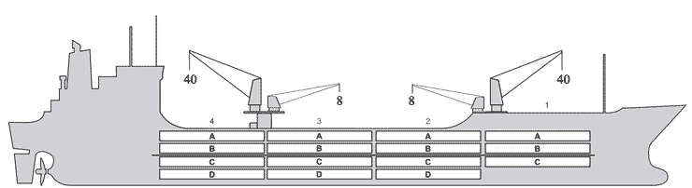

**BASICS**

|  |  |
| --- | --- |
| Flag | BAHAMAS |
| LLoydsno. | 9158549 |
| Class | RMRS |
| Int GRT/NRT | 9,298 / 4,983 |
| Pan GRT/NRT | 9,298 / 7,850 |
| Suez GRT/NRT | 9,298 / 8,050 |
| Built | 1998 |
| Lengthoverall m | 150.00 |
| Breadthmoulded m | 22.00 |
| Depth W.D. m | 13.3 |
| Sdwtmton | 11,016 |
| Draughtsdwt m | 9.268 |
| Balecbft | 535,109 |
| Area m2 | 6,003 |
| Bowthruster | 1 x 670 kw |
| Hatchcovers | 4 |
| Holds/Compartments | 4/15 |
| Fcsledeck | YES |
| Trunkdeck | NO |
| USDA | Sensorsfitted |
| PPECB | Sensorsfitted |
| Reeferplugs | 126 |
| Gratingload | 5 MT Axleload |
|  | Pneumatictires |
| Grating | Wooden |
| Tempmin/max °C | -25 /+ 15 |
| Aircircs/hour | 90 |
| Airrenew/hour | 2.5 |
|  |  |

**BALE cbft**

|  |  |  |  |  |
| --- | --- | --- | --- | --- |
| DECK & HATCH | 1 | 2 | 3 | 4 |
| A | 43,651 | 42,215 | 41,311 | 44,439 |
| B | 27,992 | 38,163 | 38,663 | 41,080 |
| C | 22,644 | 37,649 | 39,816 | 38,007 |
| D |  | 25,198 | 28,405 | 25,876 |
| Total | 94,287 | 143,225 | 148,195 | 149,402 |

Grandtotal 535,109cbft

**DECK AREA m2**

|  |  |  |  |  |
| --- | --- | --- | --- | --- |
| DECK & HATCH | 1 | 2 | 3 | 4 |
| A | 421 | 477 | 463 | 508 |
| B | 299 | 441 | 446 | 463 |
| C | 246 | 423 | 462 | 414 |
| D |  | 300 | 332 | 308 |
| Total | 966 | 1.641 | 1.703 | 1.693 |

Grand total 6,003m2

Free deckheight minimum 2.20 m

**HATCHES (Weather deck) m**

|  |  |  |  |
| --- | --- | --- | --- |
| Hatch | Length | Width | Insulated units |
|  |  |  |  |
| 1 | 7.5 | 8.5 | AB/C |
| 2 | 7.5 | 8.5 | AB/CD |
| 3 | 7.5 | 8.5 | AB/CD |
| 4 | 7.5 | 8.5 | AB/CD |

Insulated units are separate cooling sections.

**ORIENTAL REEFER**

**CARGO GEAR**

|  |  |  |  |
| --- | --- | --- | --- |
| Noof | Type | SWL mton | Location |
| **2** | **Heavy lift** | **40** | **Midship** |
| **2** | **pallet** | **8** | **Starboard side** |

**IMPORTANT!**

For working by 4 cranes vessel to be berthed **STARBOARD SIDE alongside.**

If vessel is berthed **PORT SIDE alongside** cargo operations possible by two canes only (heavy lift cranes located midship)

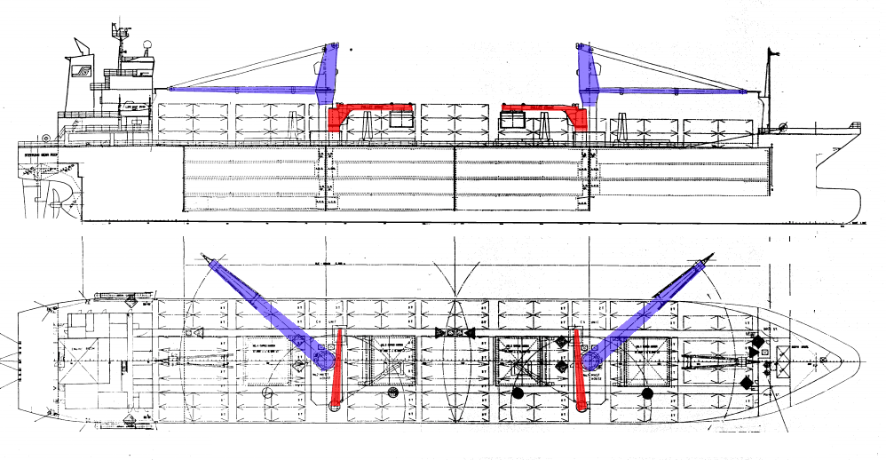

**MAXIMUM CONTAINER CAPACITY**

|  |  |  |  |
| --- | --- | --- | --- |
|  | 20 ft (8'6'') Empty/ loaded | 40 ft (9'6'') Empty/ loaded | Stackweight 20 ft/ 40 ft |
| WeatherDeck | 218/218 | 136/136 | 14mt/25mt |
| Hatchcovers |  |  |  |
| Holds | 42 | - |  |

Reefer plugs: 126

Above figures based on 14 MT for loaded 20 ft and 25 MT for loaded 40 ft Subject Master approval, Stability & Visibility

All details believed to be correct but not guaranteed