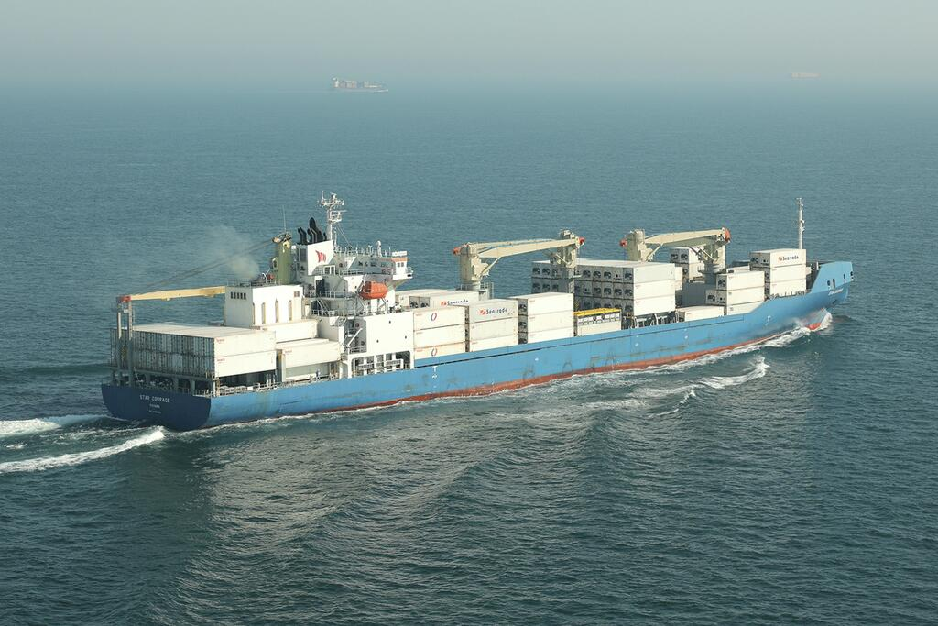



**SISTER SHIPS:** COOL SPIRIT / BALTIC SPIRIT

**General**

|  |  |
| --- | --- |
| Built | 2017 |
| Flag | Panama |
| Port of Registry | Panama |
| Call sign | XPXM |
| IMO/Lloyds nr | 9765859 |
| Length over all [m] | 188.6 |
| Beam[m] | 26 |
| Depth [m] | 14.1 |
| Bow thruster | Available |

|  |  |  |  |  |  |  |
| --- | --- | --- | --- | --- | --- | --- |
|  | | GT | | | NT | |
| International | | 17164 | | | 8092 | |
| Panama canal | |  | | | 8092 | |
| Suez GRT/NRT | | 18026.03 | 14815.33 | | | |
|  | Draft | | | DWAT | |
| Summer | 9.72m | | | 16727 t | |

**Reefer**

|  |  |
| --- | --- |
| Bale cbft | 653.310 |
| Area m2 | **7,290.7** |
| Hatch covers | 5 |
| Holds/Compartments | 4/18 Hold 3 for containers |
| Cooling sections | FC/AB, 2AB/CD, 4AB/CD, 5AB/CD |
| Fcsle deck | YES |
| Trunk deck | NO |
| USDA | Sensors fitted |
| PPECB | Sensors fitted |
| Reefer plugs | 320 |
| Grating load | 7 MT Axleload pneumatic tires |
| Grating | Wooden |
| Temp min/max °C | -30/+15 |
| Air circs/hour | 90 |
| Air renew/hour | 2 |

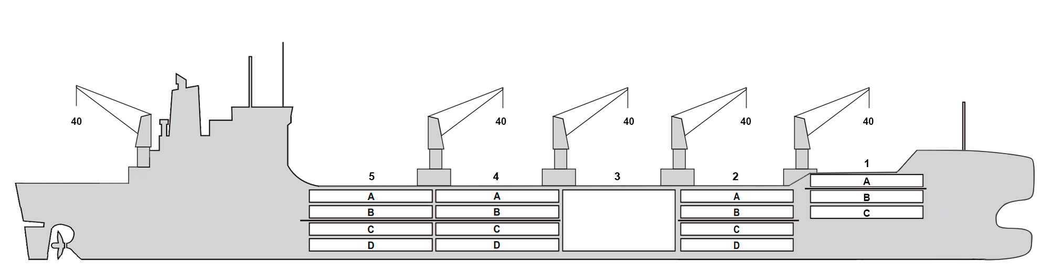

**Reefer Compartment Capacity Breakdown**

Bale capacity [cbft]

|  |  |  |  |  |  |
| --- | --- | --- | --- | --- | --- |
| **DECK & HATCH** | **1** | **2** | **3** | **4** | **5** |
| **FC** | 52303 |  |  |  |  |  |
| **A** | 29262 | 54998 |  | 54993 | 55314 |  |
| **B** | 16840 | 43232 |  | 52167 | 50514 |  |
| **C** |  | 37552 |  | 51631 | 44052 |  |
| **D** |  | 30530 |  | 41891 | 38031 |  |
| **Total** | 98405 | 166312 |  | 200682 | 187911 |  |

Grand total 653.310 cbft

Deck area [m2]

|  |  |  |  |  |  |
| --- | --- | --- | --- | --- | --- |
| DECK & HATCH | 1 | 2 | 3 | 4 | 5 |
| FC | 552 |  |  |  |  |
| A | 311 | 570.4 |  | 573.5 | 574.9 |
| B | 193 | 490.6 |  | 619.9 | 571.4 |
| C |  | 440.2 |  | 618.7 | 525.7 |
| D |  | 349.7 |  | 470.5 | 429 |
| Total | 1056 | 1850.9 |  | 2282.6 | 2101 |

Grand total 7290.7 m2  
Free deckheight minimum 2.3 m

Hatch sizes [m]

|  |  |  |  |
| --- | --- | --- | --- |
| Hatch | Length | Width | Insulated units |
| 1 | 12,6 | 10,3 | 1F/AB |
| 2 | 12,6 | 10,3 | AB/CD |
| 3 | 12,6 | 21.4 | AB/CD |
| 4 | 12,6 | 10,3 | AB/CD |
| 5 | 12,6 | 10,3 | AB/CD |

CARGO GEAR

|  |  |  |  |
| --- | --- | --- | --- |
| No | Type | SWL mton | UP mton |
| 5 | Electro hydraulic | 40 | - |

MAXIMUM CONTAINER CAPACITY

|  |  |  |  |
| --- | --- | --- | --- |
|  |  | 40 ft (9'6'') | Stackweight 20 ft/ 40 ft |
| Weather Deck |  | 180 FEU+24TEU | 48,60,96/90,100,120 |
| Hatch covers |  | 106 | 24,48,50/63.5 - 108 |
| Holds |  | 91 | 45,80,94.5/35-150 |

Total 377 FEU + 24 TEU or 586 TEU + 95 FEU

Reefer plugs: 320

*Particulars are given without guarantee and do not form part of any Charter Party agreement*