**WILD PEONY**

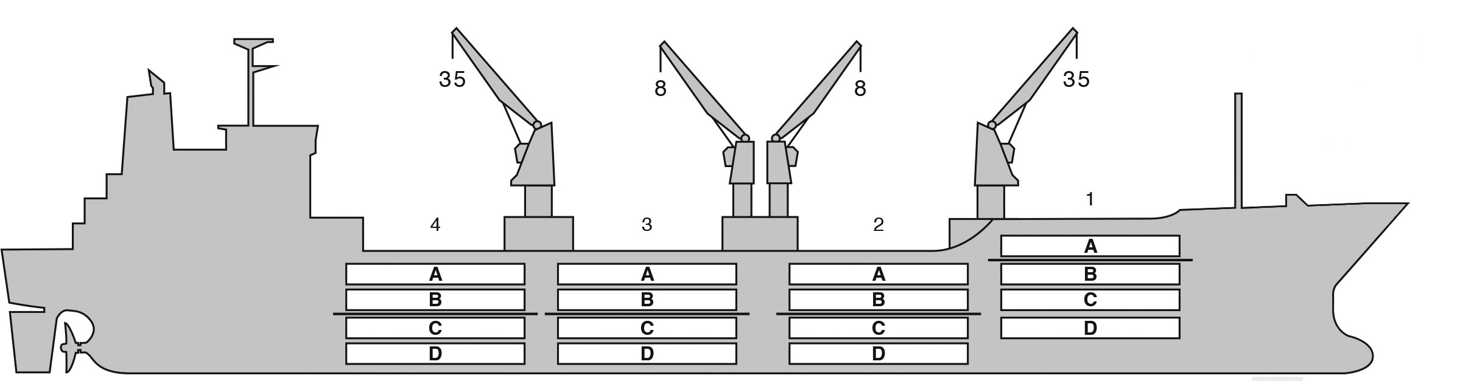

**BASICS**

|  |  |
| --- | --- |
| Flag | Bahamas |
| LLoyds no. | 9191474 |
| Class | RINA |
| Int GRT/NRT | 9,859 / 5,124 |
| Pan GRT/NRT | - / - |
| Suez GRT/NRT | 10,632 / 8,824 |
| Built | 1 998 |
| Length over all m | 149.92 |
| Breadth moulded m | 22.10 |
| Depth W.D. m | 13.0 |
| Sdwt mton | 10,097 |
| Draught sdwt m | 8.7 |
| Bale cbft | 499,900 |
| Area m2 | 5,750 |
| Bow thruster | N/A |
| Hatch covers | 4 |
| Holds/Compartmens | 4/16 |
| Fcsle deck | YES |
| Trunk deck | NO |
| USDA | Sensors fitted |
| PPECB | Sensors fitted |
| Reefer plugs | 58 |
| Grating load | 6 MT Axleload |
|  | Pneumatic tires |
| Grating | Wood |
| Temp min/max °C | -30 / 32 |
| Air circs/hour | 90 |
| Air renew/hour | 2.5 |
|  |  |

**BALE cbft**

|  |  |  |  |  |
| --- | --- | --- | --- | --- |
| DECK & HATCH | 1 | 2 | 3 | 4 |
| FC |  |  |  |  |
| A | 37,036 | 39,449 | 41,378 | 40,816 |
| B | 20,393 | 36,358 | 38,947 | 38,264 |
| C | 16,664 | 29,019 | 36,694 | 29,600 |
| D | 10,510 | 24,920 | 34,813 | 25,039 |
| Total | 84,603 | 129,746 | 151,832 | 133,719 |

Grand total 499,900

**DECK AREA m2**

|  |  |  |  |  |
| --- | --- | --- | --- | --- |
| DECK & HATCH | 1 | 2 | 3 | 4 |
| FC |  |  |  |  |
| A | 409 | 439 | 461 | 453 |
| B | 246 | 429 | 463 | 456 |
| C | 177 | 356 | 452 | 367 |
| D | 127 | 268 | 398 | 248 |
| Total | 960 | 1,492 | 1,774 | 1,524 |

Grand total 5,750

Free deckheight minimum 2.20 m

**HATCHES (Weather deck) m**

|  |  |  |  |
| --- | --- | --- | --- |
| Hatch | Length | Width | Insulated units |
|  |  |  |  |
| 1 | 7.4 | 7.4 | A/BCD |
| 2 | 7.4 | 7.4 | AB/CD |
| 3 | 7.4 | 7.4 | AB/CD |
| 4 | 7.4 | 7.4 | AB/CD |

Insulated units are separate cooling sections.

**WILD PEONY**

**CARGO GEAR**

|  |  |  |  |
| --- | --- | --- | --- |
| No of | Type | SWL mton | UP mton |
| 2 | Electro hydraulic | 35 | - |
| 2 | Electro hydraulic | 8 | - |

Max single lift cap: 2 x 35 MT / 2 x 8 MT

Max twin lift cap : N/A

**MAXIMUM CONTAINER CAPACITY**

|  |  |  |  |
| --- | --- | --- | --- |
|  | 20 ft (8'6'') Empty/ loaded | 40 ft (9'6'') Empty/ loaded | Stackweight 20 ft/ 40 ft |
| Weather Deck | 128/68 | 62 / 42 | 51,2 / 65,5 |
| Hatch covers | 32 / 32 | 16 / 16 | 24 / 30 |
| Holds | N / A | N / A | N / A |

Reefer plugs: 58

Above figures based on 14 MT for loaded 20 ft and 30 MT for loaded 40 ft Subject Master approval, Stability & Visibility

Please contact Cool Carriers for information about speed and consumption

All details believed to be correct but not guaranteed