
DITLEV
758,725 cbft / 9,010 sqm / Built 1990
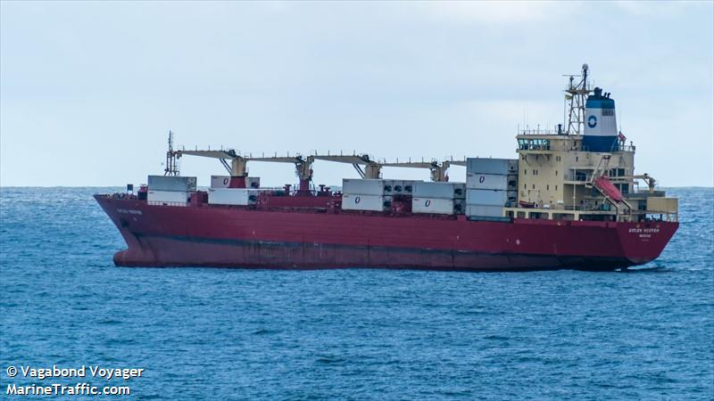
SISTER SHIPS:
KNUD
IMO 8903167 / Built 1991

IVAR
IMO 8819938 / Built 1990

JORGEN
IMO 9007489 / Built 1991

General

Built | 1990
Flag | Panama
Port of Registry | Panama
Call sign | C6ZP7
IMO/Lloyds nr | 8819926
Length over all [m] | 164,33
Beam[m] | 24
Depth [m] | 15,7
Bow thruster | yes, and stern thruster

 | GT | NT
International | 14,406 | 6,673
Panama canal | 15,481 | 12,018
Suez GRT/NRT | 15,225 | 12,234

 | Draft | DWAT
Tropical | 10,223 | 17618
Summer | 10,015 | 16950
Winter | 9,807 | 16284

Reefer

Bale cbft | 758,725
Area m2 | 9,010
Hatch covers | 9
Holds/Compartments | 5/23
Cooling sections | 1AB/C, 2345AB/CD
Fcsle deck | NO
Trunk deck | NO
USDA | Sensors fitted
PPECB | Sensors fitted
Reefer plugs | 184
Grating load | 7 MT Axleload pneumatic tires
Grating | Aluminium
Temp min/max °C | -29/15
Air circs/hour | 90
Air renew/hour | 4

DITLEV
758,725 cbft / 9,010 sqm / Built 1990
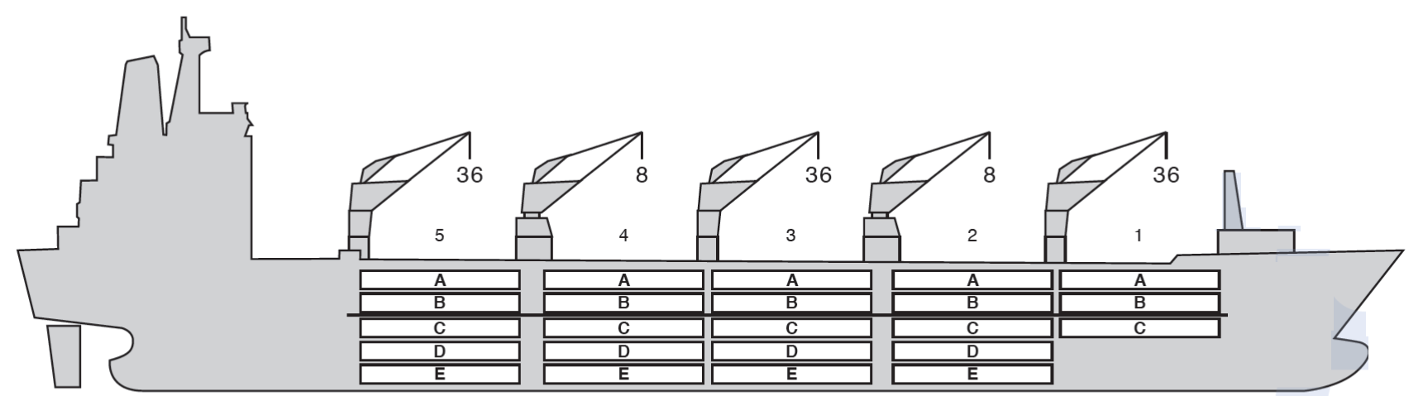

Reefer Compartment Capacity Breakdown

Bale capacity [cbft]
Grand total 758,825 cbft
DECK & HATCH | 1 | 2 | 3 | 4 | 5
A | 37,858 | 33,895 | 34,548 | 34,87 | 34,973
B | 28,81 | 32,988 | 34,319 | 34,326 | 34,174
C | 20,288 | 30,855 | 34,87 | 34,87 | 35,428
D |  | 28,037 | 34,344 | 35,538 | 34,196
E |  | 19,19 | 28,164 | 28,446 | 22,686
Total | 90,968 | 151,625 | 173,305 | 174,71 | 168,117

Deck area [m2]
 | 1 | 2 | 3 | 4 | 5
A | 423 (1.8) | 420 (1.8) | 440 (1.8) | 439 (1.8) | 440 (1.8)
B | 327 (1.8) | 391 (1.8) | 420 (1.8) | 424 (1.8) | 425 (1.8)
C | 221 (1.8) | 369 (1.8) | 439 (1.8) | 439 (1.8) | 436 (1.8)
D |  | 338 (1.8) | 429 (1.8) | 439 (1.8) | 496 (1.8)
E |  | 224 (1.8) | 360 (1.8) | 355 (1.8) | 278 (1.8)
Total | 961 | 1,742 | 2,088 | 2,096 | 1,975
Grand total 9,010 sqm

Free deckheight minimum 2.20 m
Hatch sizes [m]
Hatch | Length | Width | Insulated units
1 | 13,4 | 10,6 | ABC
2 | 2 x 13.4 | 8,8 | AB/CDE
3 | 2 x 13.4 | 8,8 | AB/CDE
4 | 2 x 13.4 | 8,8 | AB/CDE
5 | 2 x 13.4 | 8,8 | AB/CDE
CARGO GEAR
No of | Type | SWL mton | UP mton
2 | Electro hydraulic | 36 / 8 | -
2 | Electro hydraulic | 8 | -
Max single lift cap: | 2 x 8 MT / 3 x 36 MT
Max twin lift cap : | -

MAXIMUM CONTAINER CAPACITY
 | 20 ft (8’6’’)  Empty/ loaded | 40 ft (9’6’’) Empty/ loaded | Stackweight 20 ft/ 40 ft
Weather Deck | 60 / 40 | 24 / 16 | 28 - 42 / 65 - 75
Hatch covers | 220 / 144 | 110 / 74 | 28 - 42 / 65 - 75
Holds | 236 / 236 | 82 / 82 | 42 - 105 / 155
Reefer plugs: 184
Above figures based on 14 MT for loaded 20 ft and 30 MT for loaded 40 ft. Actual container intake is subject to master’s approval and depending on stability, stackweight and visibility.

