KNUD

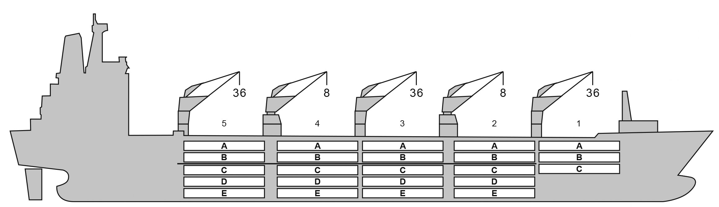

BALE cbft
BASICS

DECK & HATCH | 1 | 2 | 3 | 4 | 5
A | 37,858 | 33,895 | 34,548 | 34,870 | 34,973
B | 28,810 | 32,988 | 34,319 | 34,326 | 34,174
C | 20,288 | 30,855 | 34,870 | 34,870 | 35,428
D | - | 28,037 | 34,344 | 35,538 | 34,196
E | - | 19,190 | 28,164 | 28,846 | 22,686
Total | 90,968 | 151,625 | 173,305 | 174,710 | 168,117
Grand total | 758,725

DECK AREA m2 and DECK STRENGTH MT/m2
Aluminium
-29 / 15
90
4
Grating
Temp min/max °C Air circs/hour
Air renew/hour
Hatch covers 9
Holds/Compartments 5 / 23 Fcsle deck NO
Trunk deck NO
USDA Sensors fitted
PPECB Sensors fitted
Reefer plugs 184
Grating load 7 MT Axleload Pneumatic tires
164.33
24.00
15.7
16,950
10.1
758,725
9,010
YES, AND STERN THRUSTER
Length over all m Breadth moulded m Depth W.D. m
Sdwt mton Draught sdwt m Bale cbft
Area m2 Bow thruster
BAHAMAS 8903167 BV
14,406 / 6,673
15,481 / 12,018
15,225 / 12,234
1991
Flag LLoyds no. Class
Int GRT/NRT Pan GRT/NRT Suez GRT/NRT Built
- | 1 | 2 | 3 | 4 |  | 5
A | 435 (1.8) | 425 (1.8) | 440 (1.8) | 439 (1.8) |  | 440 (1.8)
B | 327 (1.8) | 410 (1.8) | 420 (1.8) | 424 (1.8) |  | 425 (1.8)
C | 230 (1.8) | 387 (1.8) | 439 (1.8) | 439 (1.8) |  | 436 (1.8)
D | - | 362 (1.8) | 439 (1.8) | 426 (1.8) |  | 496 (1.8)
E | - | 224 (1.8) | 360 (1.8) | 355 (
Total | 992 | 1,808 | 2,098 | 2,0
Grand total | 9,010
(Figures in brackets : max deck strength in MT/m2) Free deckheight minimum 2.20 m
1.8) 278 (1.8)
96 2,016

HATCHES (Weather deck) m
Hatch | Length | Width | Insulated units
1 | 13.4 | 10.6 | ABC
2 | 2 x 13.4 | 8.8 | AB/CDE
3 | 2 x 13.4 | 8.8 | AB/CDE
4 | 2 x 13.4 | 8.8 | AB/CDE
5 | 2 x 13.4 | 8.8 | AB/CDE
Insulated units are separate cooling sections.

KNUD

CARGO GEAR
No of | Type | SWL mton | UP mton
2 | Electro hydraulic | 36 / 8 | -
2 | Electro hydraulic | 8 | -
Max single lift cap: 2 x 8 MT / 3 x 36 MT
Max twin lift cap : -

MAXIMUM CONTAINER CAPACITY
 | 20 ft (8’6’’) | 40 ft (9’6’’) | Stackweight
 | Empty/ loaded | Empty/ loaded | 20 ft/ 40 ft
Weather Deck | 60 / 40 | 24 / 16 | 28 - 42 / 65 - 75
Hatch covers | 220 / 144 | 110 / 74 | 28 - 42 / 65 - 75
Holds | 236 / 236 | 82 / 82 | 42 - 105 / 155

Reefer plugs: 184

Above figures based on 14 MT for loaded 20 ft and 30 MT for loaded 40 ft
Subject Master approval, Stability & Visibility

Please contact Cool Carriers for information about speed and consumption All details believed to be correct but not guaranteed

