COOL EMERALD

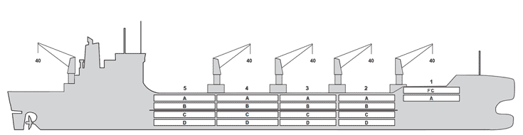

BASICS
Flag | Panama
LLoyds no. | 9982237
Class | NK
Int GRT/NRT | 22,452 / 9,657
Pan GRT/NRT | 18,709
Suez GRT/NRT | 23,272 /19,361
Built | 2025
Length over all m | 189.90
Breadth moulded m | 30.70
Depth W.D. m | 15.5
Sdwt mton | 23,169
Draught sdwt m | 10.30
Bale cbft | 904,950
Area m² | 9,672
Bow thruster | Available
Hatch covers | 5
Holds/Compartments | 5 / 18
Fcsle deck | YES
Trunk deck | NO
USDA | Sensors fitted
PPECB | Sensors fitted
Reefer plugs | 342
Grating load | 7 MT Axleload
 | Pneumatic tires
Grating | Wood
Temp min/max °C | -25 / 15
Air circs/hour | 90
Air renew/hour | 2.5

BALE cbft
DECK & HATCH | 1 | 2 | 3 | 4 | 5
FC | 34,542
A | 17,301 | 56,801 | 72,410 | 72,445 | 65,494
B |  | 35,891 | 61,515 | 65,644 | 58,732
C |  | 28,778 | 56,140 | 65,442 | 58,157
D |  | 20,596 | 46,167 | 38,398 | 50,497
Total | 51,843 | 142,066 | 236,232 | 241,929 | 232,880
Grand total 904,950
DECK AREA m2
DECK & HATCH | 1 | 2 | 3 | 4 | 5
FC | 351
A | 179 | 554 | 727 | 727 | 645
B |  | 396 | 683 | 729 | 647
C |  | 316 | 622 | 725 | 639
D |  | 229 | 515 | 427 | 561
Total | 530 | 1,495 | 2,547 | 2,608 | 2,492
Grand total 9,672
Free deckheight minimum 2.50 m
HATCHES (Weather deck) m
Hatch | Length | Width | Insulated units
1 | 6.65 | 10.3 | 1F/A
2 | 12.6 | 10.3 | AB/CD
3 | 12.6 | 10.3 | AB/CD
4 | 12.6 | 10.3 | AB/CD
5 | 12.6 | 10.3 | AB/CD
Insulated units are separate cooling sections.

COOL EMERALD

CARGO GEAR
No of | Type | SWL mton | UP mton
5 | Electro hydraulic | 40 | -
Max single lift cap: 5 x 40 MT
Max twin lift cap : 40MT

MAXIMUM CONTAINER CAPACITY
 | 20 ft (8'6'') Empty/ loaded | 40 ft (9'6'') Empty/ loaded | Stackweight 20 ft/ 40 ft
Weather Deck | 312/ 312 | 254/ 254 | 60,0 / 124,0
Hatch covers | 132 / 132 | 88 / 88 | 50,0 / 124,0
Holds | 120 / 120 | 58 / 58 | 80,0 / 124,0

Reefer plugs: 342
Above figures based on 14 M for loaded 20 ft and 25 MT for loaded 40 ft Subject Master approval, Stability & Visibility
Please contact Cool Carriers Ltd for information about speed and consumption
All details believed to be correct but not guaranteed

