
CS BEST
617,261 cbft / 6,874.5sqm / Built 2006
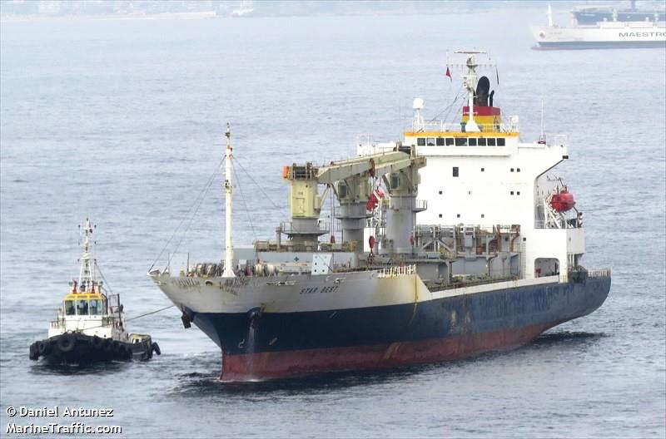

General
Built | October – 2006 |  |  | GT | NT
Flag | Singapore |  | International | 14,194.0 | 6724
Port of Registry | Singapore |  | Panama canal | 14,194.0 | 12,244.0
Call sign | 9V9357 |  | Suez GRT/NRT | 14,857.74 | 12,312.94
IMO/Lloyds nr | 9350989
Length over all [m] | 162,5 |  |  | Draft | DWAT
Beam[m] | 26 |  | Tropical | 9,922 | 13,874
Depth [m] | 14,1 |  | Summer | 9,72 | 13,107
Bow thruster | 800 KW / 1000HP |  | Winter | 9,518 | 13,107
Fresh Water | 9.887 / 13,121 |  | Tropical FW | 10,089 | 13,787

Reefer
Bale cbft | 617,261
Area m2 | 6,874.5
Hatch covers | 4
Holds/Compartments | 4/15
Cooling sections | 1F/AB,2AB/CD,3AB/CD,4AB/CD
Fcsle deck | YES
Trunk deck | NO
USDA | Sensors fitted
PPECB | Sensors fitted
Reefer plugs | 200
Grating load | 6 MT Axle load with pneumatic rubber tires
Grating | Wood
Temp min/max °C | -25/+15
Air circs/hour | 90
Air renew/hour | 2
Clear deck height | 2.30 m

CS BEST
617,261 cbft / 6,874.5sqm / Built 2006

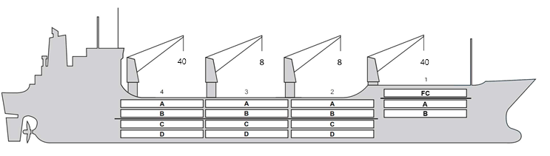
Reefer Compartment Capacity Breakdown

Bale capacity [cbft]
DECK & HATCH | 1 | 2 | 3 | 4
FC | 55857
A | 30406 | 54024 | 54106 | 52499
B | 18402 | 43434 | 49575 | 45468
C |  | 37232 | 45863 | 37239
D |  | 30533 | 33842 | 28781
Total | 104665 | 165223 | 183386 | 163987
Grandtotal 617,261cbft

Deck area [m2]
DECK & HATCH | 1 | 2 | 3 | 4
FC | 589.7
A | 326.3 | 558.8 | 560.6 | 541.6
B | 211.8 | 493.9 | 563.1 | 516.9
C |  | 444.7 | 549.3 | 444.8
D |  | 350.9 | 390.2 | 331.9
Total | 1127.8 | 1848.3 | 2063.2 | 1835.2
Grand total 6874.5 m2

Cargo space volume is including the hatch way volume
Hatch sizes [m]
Hatch | Length | Width | Insulated units
1 | 12.6/10.29 | 10.3/6.0 | FC/AB
2 | 12.6 | 10,3 | AB/CD
3 | 12.6 | 10,3 | AB/CD
4 | 12.3 | 10,3 | AB/CD

CARGO GEAR
No | Type | SWL mton | UP mton
1,4 | hydraulic | 40 | -
2,3 | hydraulic | 8 | -
Max single lift cap: N/A
Max twin lift cap : N/A

MAXIMUM CONTAINER CAPACITY
 | 20 ft (8'6'') | 40 ft (8'6'') | 40 ft (9'6'') | Stackweight 20 ft/ 40 ft
WeatherDeck | 184 | 150 | 150 | 60 / 60,90,108
Hatchcovers | 140 | 70 | 70 | 40,50 / 60,108
Holds | 112 | 56 | 56 | 45,25,80 / 60,35,120
Reefer plugs: 200
Note: Maximum Reefer container capacity is approx 171 FEU at 27 MT for loaded 40 ft. Maximum container load for particular voyage is subject to Stability, Stack weight limitations, Visibility from bridge and masters approval.

