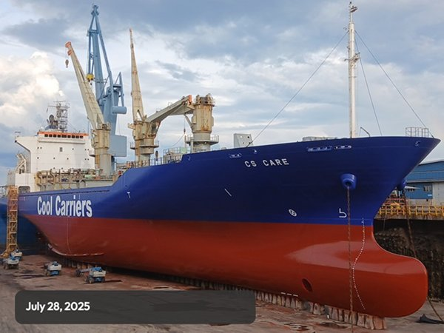
SISTER SHIPS: CS PRIDE / CS ENDEAVOUR / CS LEADER
General
Built | 2009
Flag | SINGAPORE
Port of Registry | SINGAPORE
Call sign | 9V9352
IMO/Lloyds nr | 9517903
Length over all [m] | 162.5
Beam[m] | 26
Depth [m] | 14.1
Bow thruster | Available

 |  | GT |  |  | NT
International |  | 14276 |  |  | 6724
Panama canal |  |  |  |  | 6724
Suez GRT/NRT |  | 14852.64 | 12285.02
 | Draft |  |  | DWAT
Summer | 9.72m |  |  | 12824 t

Reefer
Bale cbft | 617.919
Area m2 | 6852.5
Hatch covers | 4
Holds/Compartments | 4/15
Cooling sections | 1FC/AB, 2AB/CD, 3AB/CD, 4AB/CD
Fcsle deck | YES
Trunk deck | NO
USDA | Sensors fitted
PPECB | Sensors fitted
Reefer plugs | 200
Grating load | 7 MT Axleload pneumatic tires
Grating | Wooden
Temp min/max °C | -25/+15
Air circs/hour | 90
Air renew/hour | 2
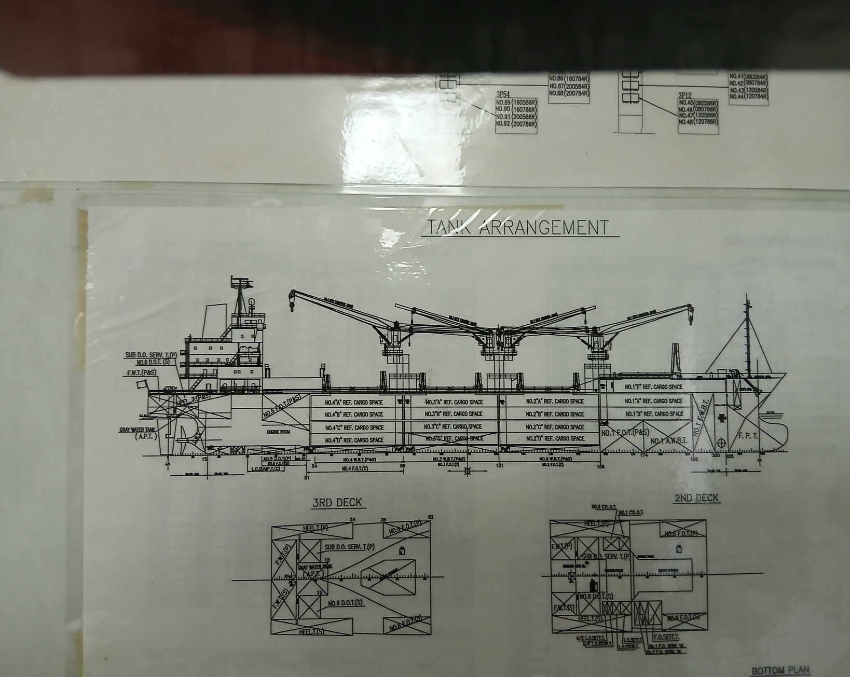

Reefer Compartment Capacity Breakdown

Bale capacity [cbft]
DECK & HATCH | 1 | 2 |  | 3 | 4
FC | 55860.7
A | 30356.5 | 54140.9 |  | 54098.5 | 52505.9
B | 18420.1 | 43557.1 |  | 49613.6 | 45538.3
C |  | 37338.2 |  | 45997.4 | 37320.5
D |  | 30533.1 |  | 33849.1 | 28788.5
Total | 104637 | 165569 |  | 183559 | 164154
Grand total 617.919 cbft

Deck area [m2]
DECK & HATCH | 1 | 2 |  | 3 | 4
FC | 589.7
A | 325.7 | 560.3 |  | 560.5 | 541.7
B | 212 | 495.4 |  | 563.6 | 517.8
C |  | 446.0 |  | 550.8 | 445.8
D |  | 350.9 |  | 390.3 | 332.0
Total | 1127.4 | 1852.6 |  | 2065.2 | 1837.3
Grand total 6852.5 m2
Free deckheight minimum 2.3 m
Hatch sizes [m]
Hatch | Length | Width | Insulated units
1 | 12,6 | 10,3 | 1F/AB
2 | 12,6 | 10,3 | AB/CD
3 | 12,6 | 10.3 | AB/CD
4 | 12,6 | 10,3 | AB/CD

CARGO GEAR
No | Type | SWL mton | UP mton
4 | Electro hydraulic | 40/8 | -

MAXIMUM CONTAINER CAPACITY
 |  | 40 ft (9'6'') | Stackweight 20 ft/ 40 ft
Weather Deck |  | 150 FEU+58TEU | 60,/90-108
Hatch covers |  | 70 | 40,50/60 - 108
Holds |  | 56 | /80-120
Total 276 FEU or 436 TEU + 58 FEU
Reefer plugs: 200

Particulars are given without guarantee and do not form part of any Charter Party agreement

