
CS LEADER
615,443 cbft / 6,852.5sqm / Built 2010

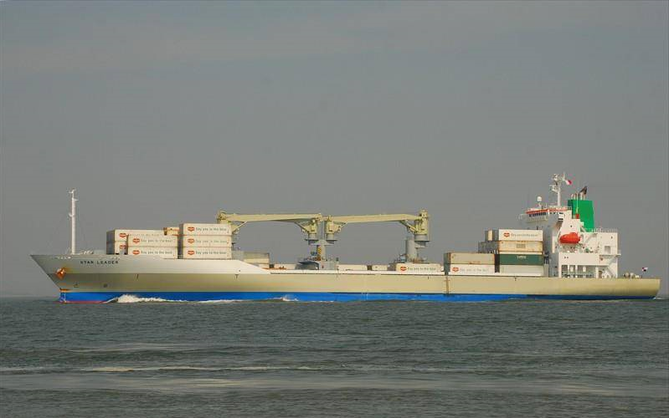

General
Built | April – 2010 |  |  | GT | NT
Flag | Singapore |  | International | 14,276 | 6,724
Port of Registry | Singapore |  | Panama canal | 14,276 | 11,977
Call sign | 9V9350 |  | Suez GRT/NRT | 14,852.64 | 12,285.02
IMO/Lloyds nr | 9517939
Length over all [m] | 162,5 |  |  | Draft | DWAT
Beam[m] | 26 |  | Tropical | 9,922 | 13,482
Depth [m] | 14,1 |  | Summer | 9,720 | 12,811
Bow thruster | 800 KW / 1000HP |  | Winter | 9,518 | 12,153
Fresh Water | 9.887 12.953 |  | Tropical FW | 10,089 | 13,482

Reefer
Bale cbft | 615,506
Area m2 | 6,852.5
Hatch covers | 4
Holds/Compartments | 4/15
Cooling sections | 1F/AB,2AB/CD,3AB/CD,4AB/CD
Fcsle deck | YES
Trunk deck | NO
USDA | Sensors fitted
PPECB | Sensors fitted
Reefer plugs | 200
Grating load | 6 MT Axle load with pneumatic rubber tires
Grating | Wood
Temp min/max °C | -25/+15
Air circs/hour | 90
Air renew/hour | 2
Clear deck height | 2.30 m

CS LEADER
615,443 cbft / 6,852.5sqm / Built 2010

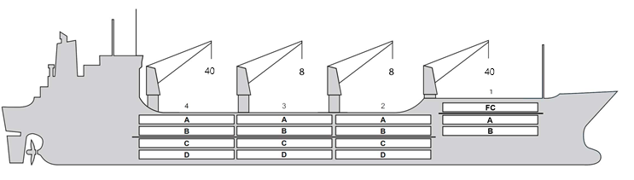
Reefer Compartment Capacity Breakdown

Bale capacity [cbft]
DECK & HATCH | 1 | 2 | 3 | 4
FC | 55946
A | 30342 | 54109 | 54144 | 52598
B | 18109 | 42904 | 49105 | 45330
C |  | 36763 | 45612 | 37352
D |  | 30498 | 33867 | 28764
Total | 104397 | 164274 | 182728 | 164044
Grandtotal 615 443 cbft

Deck area [m2]
DECK & HATCH | 1 | 2 | 3 | 4
FC | 590.7
A | 325.6 | 559.9 | 561.0 | 542.8
B | 208.2 | 487.5 | 557.4 | 515.3
C |  | 439.0 | 546.2 | 446.2
D |  | 350.5 | 390.5 | 331.7
Total | 1124.5 | 1836.9 | 2055.1 | 1836.0
Grand total 6852.5 m2

Cargo space volume is including the hatch way volume
Hatch sizes [m]
Hatch | Length | Width | Insulated units
1 | 12.6 | 10.3 | FC/AB
2 | 12.6 | 10,3 | AB/CD
3 | 12.6 | 10,3 | AB/CD
4 | 12.6 | 10,3 | AB/CD

CARGO GEAR
No | Type | SWL mton | UP mton
1,4 | hydraulic | 40 | -
2,3 | hydraulic | 8 | -
Max single lift cap: N/A
Max twin lift cap : N/A

MAXIMUM CONTAINER CAPACITY
 | 20 ft (8'6'') | 40 ft (8'6'') | 40 ft (9'6'') | Stackweight 20 ft/ 40 ft
WeatherDeck | 184 | 150 | 150 | 60 / 60,90,108
Hatchcovers | 140 | 70 | 70 | 40,50 / 60,108
Holds | 112 | 56 | 56 | 45,25,80 / 60,35,120
Reefer plugs: 200
Note: Maximum Reefer container capacity is approx 171 FEU at 27 MT for loaded 40 ft. Maximum container load for particular voyage is subject to Stability, Stack weight limitations, Visibility from bridge and masters approval.

