CS PRIDE
615,390 cbft / 6,851.8 sqm / Built 2009

General
Built | 18th Dec. 2009 |  |  | GT | NT
Flag | Singapore |  | International | 14,276 | 6724
Port of Registry | Singapore |  | Panama canal |  | 11,977
Call sign | 9V9351 |  | Suez GRT/NRT | 14,852.64 | 12,285.02
IMO/Lloyds nr | 9517915
Length over all [m] | 162,5 |  |  | Draft | DWAT
Beam[m] | 26 |  | Tropical | 9,922 | 13,992.59
Depth [m] | 14,1 |  | Summer | 9,720 | 12,821.59
Bow thruster | 800 KW / 1072HP |  | Winter | 9,518 | 12,163.59
Fresh Water | 9.887 |  | Tropical FW | 10,089 | 13,992.59

Reefer
Bale cbft | 615,390
Area m2 | 6,851.8
Hatch covers | 4
Holds/Compartments | 4/15
Cooling sections | 1F/AB,2AB/CD,3AB/CD,4AB/CD
Fcsle deck | YES
Trunk deck | NO
USDA | Sensors fitted
PPECB | Sensors fitted
Reefer plugs | 200
Grating load | 6 MT Axle load with pneumatic rubber tires
Grating | Wood
Temp min/max °C | -25°C/+32°C
Air circs/hour | 90
Air renew/hour | 2

CS PRIDE
615,390 cbft / 6,851.8 sqm / Built 2009

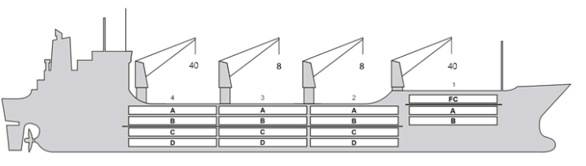
Reefer Compartment Capacity Breakdown

Bale capacity [cbft]
DECK & HATCH | 1 | 2 | 3 | 4
FC | 55854
A | 30427 | 54102 | 54180 | 52594
B | 17996 | 42914 | 49105 | 45337
C |  | 36770 | 45574 | 37359
D |  | 30537 | 33870 | 28771
Total | 104277 | 164323 | 182729 | 164061
Grandtotal 615,390 cbft

Deck area [m2]
DECK & HATCH | 1 | 2 | 3 | 4
FC | 589.6
A | 326.6 | 559.8 | 561.5 | 542.8
B | 206.9 | 487.6 | 557.4 | 515.3
C |  | 439.1 | 545.7 | 446.2
D |  | 350.9 | 390.6 | 331.8
Total | 1123.1 | 1837.4 | 2055.2 | 1836.1
Grand total 6851.8 m2

Cargo space volume is including the hatch way volume
Hatch sizes [m]
Hatch | Length | Width | Insulated units
1 | 12.6/10.29 | 10.3/6.0 | FC/AB
2 | 12.6 | 10,3 | AB/CD
3 | 12.6 | 10,3 | AB/CD
4 | 12.6 | 10,3 | AB/CD

CARGO GEAR
No | Type | SWL mton | UP mton
1,4 | hydraulic | 40 | -
2,3 | hydraulic | 8 | -
Max single lift cap: N/A
Max twin lift cap: N/A

MAXIMUM CONTAINER CAPACITY
 | 20 ft (8'6'') | 40 ft (8'6'') | 40 ft (9'6'') | Stackweight 20 ft/ 40 ft
WeatherDeck | 184 | 140 | 140 | 60 / 60,90,108
Hatchcovers | 140 | 80 | 80 | 40,50 / 60,108
Holds | 112 | 56 | 56 | 45,25,80 / 60,35,120
Reefer plugs: 200
Note: Maximum Reefer container capacity is approx. FEU at 27 MT for loaded 40 ft. Maximum container load for particular voyage is subject to Stability, Stack weight limitations, Visibility from bridge and masters approval.

