CS SERVICE
618,165 cbft / 6,885.3sqm / Built 2007

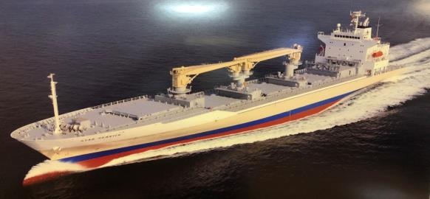

General
Built | 02 August 2007 |  |  | GT | NT
Flag | Singapore |  | International | 14,284.0 | 6724
Port of Registry | Singapore |  | Panama canal | 14,284.0 | 11,983
Call sign | 9V9398 |  | Suez GRT/NRT | 14,856.62 | 12,285.75
IMO/Lloyds nr | 9438482
Length over all [m] | 162,5 |  |  | Draft | DWAT
Beam[m] | 26 |  | Tropical | 9,922 | 13,877
Depth [m] | 14,1 |  | Summer | 9,720 | 13,207
Bow thruster | 800 KW / 1072HP |  | Winter | 9,518 | 12,550
Fresh Water | 9.887 |  | Tropical FW | 10,089 | 13,877

Reefer
Bale cbft | 618,165
Area m2 | 6,885.3
Hatch covers | 4
Holds/Compartments | 4/15
Cooling sections | 1F/AB,2AB/CD,3AB/CD,4AB/CD
Fcsle deck | YES
Trunk deck | NO
USDA | Sensors fitted
PPECB | Sensors fitted
Reefer plugs | 200
Grating load | 6 MT Axle load with pneumatic rubber tires
Grating | Wood
Temp min/max °C | -25°C/+32°C
Air circs/hour | 90
Air renew/hour | 2

CS SERVICE
618,165 cbft / 6,885.3 sqm / Built 2007

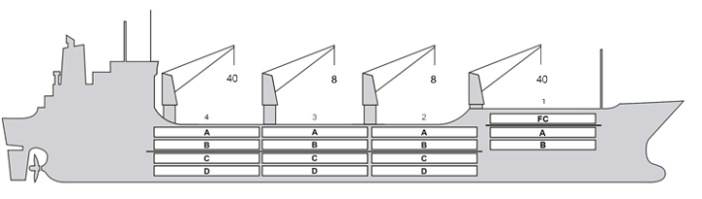
Reefer Compartment Capacity Breakdown

Bale capacity [cbft]
DECK & HATCH | 1 | 2 | 3 | 4
FC | 55957
A | 30441 | 54149 | 54152 | 52448
B | 18448 | 43524 | 49613 | 45499
C |  | 37277 | 46121 | 37302
D |  | 30552 | 33828 | 28854
Total | 104846 | 165502 | 183714 | 164103
Grandtotal 618,165 cbft

Deck area [m2]
DECK & HATCH | 1 | 2 | 3 | 4
FC | 590.8
A | 326.8 | 560.8 | 561.2 | 540.9
B | 212.3 | 495.9 | 563.5 | 517.4
C |  | 444.2 | 552.3 | 445.5
D |  | 350.8 | 390.1 | 332.8
Total | 1129.9 | 1851.7 | 2067.1 | 1836.6
Grand total 6885.3 m2

Cargo space volume is including the hatch way volume
Hatch sizes [m]
Hatch | Length | Width | Insulated units
1 | 12.6/10.29 | 10.3/6.0 | FC/AB
2 | 12.6 | 10,3 | AB/CD
3 | 12.6 | 10,3 | AB/CD
4 | 12.6 | 10,3 | AB/CD

CARGO GEAR
No | Type | SWL mton | UP mton
1,4 | hydraulic | 40 | -
2,3 | hydraulic | 8 | -
Max single lift cap: N/A
Max twin lift cap: N/A

MAXIMUM CONTAINER CAPACITY
 | 20 ft (8'6'') | 40 ft (8'6'') | 40 ft (9'6'') | Stackweight 20 ft/ 40 ft
WeatherDeck | 184 | 140 | 140 | 60 / 60,90,108
Hatchcovers | 140 | 80 | 80 | 40,50 / 60,108
Holds | 112 | 56 | 56 | 45,25,80 / 60,35,120
Reefer plugs: 200
Note: Maximum Reefer container capacity is approx. FEU at 27 MT for loaded 40 ft. Maximum container load for particular voyage is subject to Stability, Stack weight limitations, Visibility from bridge and masters approval.

