SNOW FLOWER

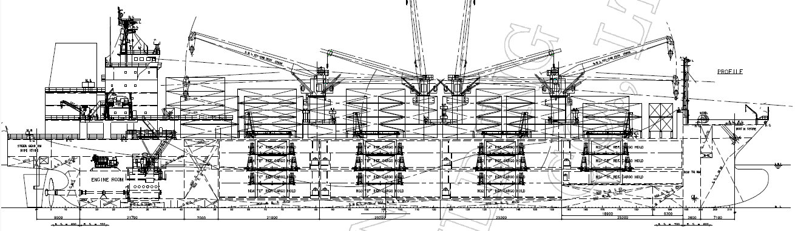

BASICS
Flag | SINGAPORE
LLoyds no. | 1039761
Class | NK
Int GRT/NRT | 13287 / 6314
Pan GRT/NRT | /
Suez GRT/NRT | /
Built | 2026
Length over all m | 158
Breadth moulded m | 25.0
Depth W.D. m | 14.35
Sdwt mton | 14549,06
Designed loaded draft, mould m | 8.95
Bale cbft | 637 696
Area m² | 6483,39
Bow thruster
Hatch covers | 4
Holds/Compartments | 4/15
Fcsle deck | NO
Trunk deck | NO
USDA | Sensors fitted
PPECB | Sensors fitted
Reefer plugs | 150
Grating load | Forklift with minimum 4 pneumatic rubber tires up to 6 mt total truck+cargo
Grating | wood
Temp min/max °C | -25 / +15
Air circs/hour | 90
Air renew/hour | 1.5/3 times

BALE cbft
DECK & HATCH | 1 | 2 | 3 | 4
A | 37667 | 52720 | 53237 | 43351
B | 25072 | 48589 | 51743 | 43124
C | 20663 | 44917 | 53868 | 43209
D | -- | 33799 | 48948 | 36789
Total | 83402 | 180025 | 207796 | 166473
Grand total 637 696 cbft
DECK AREA m2
DECK & HATCH | 1 | 2 | 3 | 4
A | 339,64 | 561,70 | 576,95 | 473,29
B | 240,63 | 495,01 | 548,94 | 452,04
C | 204,64 | 440,41 | 568,19 | 451,39
D | -- | 298,43 | 485,82 | 346,31
Total | 784,91 | 1795,55 | 2179,90 | 1723,03
Grand total 6483,39 m2
Free deckheight minimum 2.50 m
HATCHES (Weather deck) m
Hatch | Length | Width | Insulated units
1 | 7.0 | 8.0 | AB/C
2 | 7.0 | 8.0 | AB/CD
3 | 7.0 | 8.0 | AB/CD
4 | 7.0 | 8.0 | AB/CD
Insulated units are separate cooling sections.

SNOW FLOWER
CARGO GEAR
Cranes
Nos. 1 : Cylinder luffing type Container handling deck crane
40t / 8t SWL
(hoisting speed) 14 / 42 m/min. (at 40t / 8t mode)
(slewing radius) Max. 24 m
(slewing speed) 0.35 or 1.4 rpm

Nos. 2&3 : Cylinder luffing type Pallet handling deck crane
8t SWL x 2 set
(hoisting speed) 70 m/min.
(slewing radius) Max. 22 m
(slewing speed) 1.2 rpm

Nos. 4 : Cylinder luffing type Container handling deck crane
40t / 8t SWL
(hoisting speed) 14 / 42 m/min. (at 40t / 8t mode)
(slewing radius) Max. 26 m
(slewing speed) 0.35 or 1.4 rpm

MAXIMUM CONTAINER CAPACITY
On deck & hatch cover: 152 feu + 10 teu or 154 teu + 74 feu
In cargo hold : 45 TEU
(total) : 152 FEU + 55 TEU or 199 TEU + 74 FEU
Reefer plug : 150 plugs on deck
Speed and Daily Fuel Consumption
In good weather condition i.e. up to Beaufort Force 4 and Douglas scale 3, no swell nor adverse current, and clean bottom.
Bunker grade HFO/VLSFO (IF-380CST) ISO8217 RMG380 and MGO ISO8217 DMB.
Bunker quality shall be suitable for burning in the vessel’s machineries.
Vessel entitles to use more marine gas oil at narrow / shallow / busy water area,
canals, in and out of ports and engine starting / stopping.

Service Speed:
Ballasted cond. Designed laden cond. Fully laden cond.
(draft abt. 6.15m) (draft abt. 8.95m) (draft abt.9.7m)
For 1st- 4th yr abt. 18.8 knots abt. 18.5 knots abt. 18.0 knots
5th- 7th yr abt. 18.6 knots abt. 18.3 knots abt. 17.7 knots
8th- 10th yr abt. 18.3 knots abt. 18.0 knots abt. 17.4 knots

M/E Consumption at sea for above 3 cases:
abt. 35.2 MT/day VLSFO
or abt. 37.0 MT/day HFO when operating open loop SOx Scrubber

A/E Consumption in port :
VLSFO Marine Gas Oil
In port (Idle) abt. 2.3 MT abt. 0.2 MT

At sea (Ballasted condition without cargo)①
abt. 3.6 MT abt. 0.2 MT

At sea (at banana keeping condition without reefer container and c.a. operation)
abt. 9.1 MT abt. 0.2 MT

At sea (Banana keeping condition + abt. 130 FEU reefer containers on deck
without c.a. operation) abt. 13.7 MT abt. 0.2 MT

(Remarks)
1) Additional consumption of about 1.2Mt/day for aux. engines is required during using SOx Scrubber and consuming HFO.(example,①FOC HFO 3.6+1.2MT+MGO 0.2MT)
2) In winter condition, additional consumption of MGO about 1.2 MT/day for aux. boiler is required.
3) Additional consumption for aux. engines is required in case of loading reefer containers and for cooling down operation.

All details believed to be correct but not guaranteed

