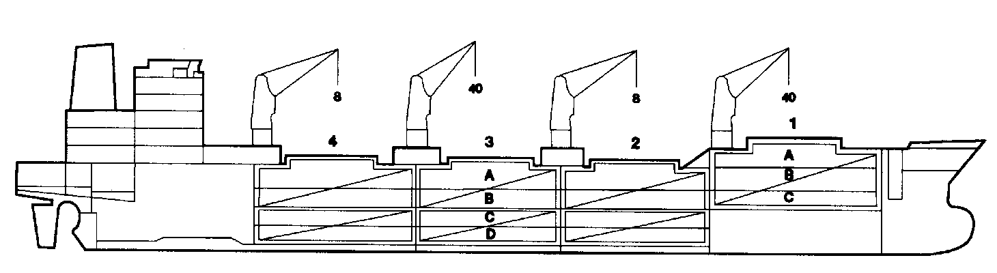
Southampton Reefer

BASICS
Flag | Bahamas
LLoyds no. | 9206059
Class | NK 1A1 Reefer
Int GRT/NRT | 10,804 / 5,320
Pan GRT/NRT | - / 9,313
Suez GRT/NRT | 11,703 / 9,710
Built | Japan, 1999
Length over all m | 150.0
Breadth moulded m | 23.0
Depth W.D. m | 13.3
Sdwt mton | 9709
Draught sdwt m | 9.02
Bale cbft | 506,228
Area m² | 5,944.3
Bow thruster | N/A
Hatch covers | 4
Holds/Compartmens | 4/15
Fcsle deck | YES
Trunk deck | NO
USDA | Sensors fitted
PPECB | Sensors fitted
Reefer plugs | 100
Grating load | 6 MT Axleload
 | Pneumatic tires
Grating
Temp min/max °C | -25 / +15
Air circs/hour | 90
Air renew/hour | 2

BALE cbft
DECK & HATCH | 1 | 2 | 3 | 4
FC
A | 42,197 | 42,699 | 42,515 | 44,617
B | 25,861 | 35,071 | 38,931 | 38,323
C | 15,630 | 30,025 | 37,271 | 31,416
D |  | 22,351 | 34,043 | 25,278
Total | 83,688 | 130,146 | 152,760 | 139,634
Grand total 506,228
DECK AREA m2
DECK & HATCH | 1 | 2 | 3 | 4
FC
A | 462.9 | 472.1 | 470.3 | 496.7
B | 285.6 | 423.6 | 467.0 | 461.0
C | 183.7 | 373.5 | 465.6 | 391.2
D |  | 273.2 | 409.3 | 308.6
Total | 932.2 | 1542.4 | 1812.2 | 1657.5
Grand total 6,226
Free deckheight minimum 2.20 m
HATCHES (Weather deck) m
Hatch | Length | Width | Insulated units
1 | 12.6 | 7.8 | ABC
2 | 12.6 | 7.8 | AB/CD
3 | 12.6 | 7.8 | AB/CD
4 | 12.6 | 7.8 | AB/CD
Insulated units are separate cooling sections.

Southampton Reefer

CARGO GEAR
No of | Type | SWL mton | UP mton
2 | Hydraulic | 40 | -
2 | Hydraulic | 8 | -
Max single lift cap: 2 x 40 MT / 2 x 8 MT
Max twin lift cap : N/A

MAXIMUM CONTAINER CAPACITY
 | 8’6” |  | 9’6” | Stackweight (20’/40’)
 | 20 ft | 40ft | 40 ft | No. 1 | Nos. 2-4
Hatch covers | 80 | 40 | 40 | 20/30 | 40/60
Weather Deck | 142 | 68 | 68 | 20/30 | 60/90
Holds | 84 | 42 | 42 | 40/60 | 80/120*
Totals | 306 | 150 | 150

100 reefer sockets on deck (20 ft and/or 40 ft)
*On tank top. On ‘A’ deck covers 20/30 tonnes.
** Maximum reefer container capacity is 90 units at 25 tonnes gross. Maximum container load for a particular voyage is subject to stability, stackweight limitations, visibility from bridge and Master’s approval.
Please contact Cool Carriers for information about speed and consumption
All details believed to be correct but not guaranteed

